# Waste Disposal Practices

Effective waste disposal practices in the laboratory are important for maintaining a safe and clean environment. These practices include separating waste into biological, sharps, nonhazardous, or universal categories. Waste disposal regulations vary at the state and local levels, and all waste disposals must comply with local, regional, state, national, and international regulations.

## Biological Waste Disposal

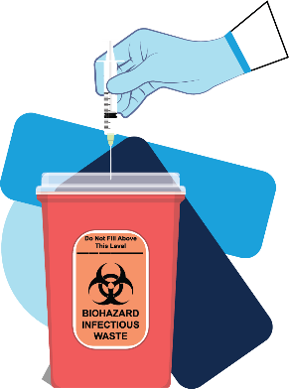 Biological waste includes any material that has been contaminated or potentially contaminated by or that contains a biohazardous agent. All waste being removed from a laboratory must be decontaminated (Exception: general waste from biosafety level BSL-1 and BSL-2 laboratories).

What are examples of biological waste? **Select all that apply.**

* Pipette tips, pipettes, plastic tubes, vials, and petri dishes
* Biological cultures, specimens, and tissue samples
* Sharps in a sharps container
* Disposable gloves and gowns

## WastewaterDisposal

 Substances poured down laboratory drains have specific disposal requirements. No hazardous wastes (**biological, radiological, or chemical**) are permitted to go down the drain. Additionally, chemicals cannot be diluted for the sole purpose of drain disposal.

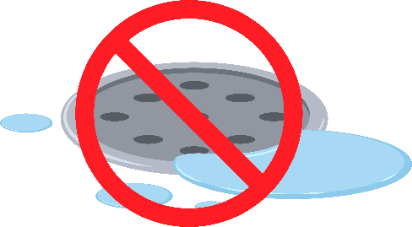What may be poured down the drain? **Select all that apply.**

* Biological hazard
* Radiological hazard
* Chemical hazard

**Important- If in doubt, do NOT put waste down the drain! Contact your supervisor or laboratory safety staff if you have questions about what can be discarded down the drain.**

## NonhazardousWasteDisposal

Nonhazardous waste is any material not contaminated by a biohazardous, radiological, or chemical agent in a BSL-1 or 2 laboratory. Nonhazardous waste can usually be discarded in your general waste stream.

What items can be discarded in your general waste stream? **Select all that apply.**

* Paper towels used to dry your hands
* Boxes and inserts
* Used face mask
* Test tubes
* Pipette tip boxes

## Universal Waste Disposal

 Universal waste comes primarily from consumer products containing mercury, lead, cadmium, and other substances that are hazardous to human health and the environment. These items cannot be discarded in the municipal waste stream or disposed of in landfills. Instead, they are collected so professionals can reclaim some components of them and dispose of other parts.

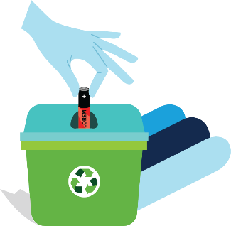What universal wastes cannot be discarded in the municipal waste stream or disposed of in landfills? **Select all that apply.**

* Batteries (excluding alkaline batteries)
* Fluorescent or ultraviolet lamps
* Items that contain mercury (thermometers, thermostat switches)
* Paper towels