**Self-Assessment Checklist for Good Testing Practices**

This checklist emphasizes recommended practices for physicians, nurses, medical assistants, pharmacists, and others who perform patient testing under a Clinical Laboratory Improvement Amendments (CLIA) Certificate of Waiver. It can be used as a voluntary tool to help assure good testing practices and reliable, high-quality test results.

Sites that perform testing under a CLIA Certificate of Waiver must meet the following requirements:

* Enroll in the CLIA program
* Pay applicable certificate fees biennially
* Follow the current manufacturer’s instructions provided with the test

Additional resources to supplement this checklist can be found here: [Waived Tests | Laboratory Quality | CDC](https://www.cdc.gov/lab-quality/php/waived-tests/?CDC_AAref_Val=https://www.cdc.gov/labquality/waived-tests.html)

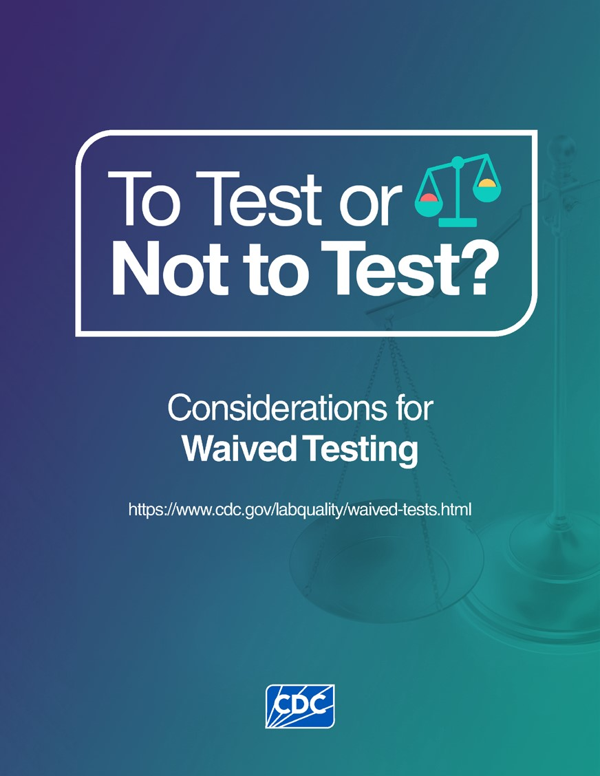

**Disclaimer:** Although some of the recommendations in this self-assessment checklist exceed CLIA requirements for waived testing, following these good testing practices will likely lead to reliable, high-quality test results and will enhance patient safety.

**Self-Assessment Checklist for Good Testing Practices**

**Note:** When reviewing this checklist, consider your laboratory or testing site. Mark “Yes” or “No” as applicable. For items marked “No,” consult the individual responsible for overseeing or directing testing to determine the appropriate corrective actions. Document any corrective actions taken.

|  |  |  |  |
| --- | --- | --- | --- |
| **REGULATORY REQUIREMENTS** | **Yes** | **No** | **N/A** |
| Does your laboratory or testing site perform only CLIA waived tests?  Search for tests categorized as waived: <https://www.accessdata.fda.gov/scripts/cdrh/cfdocs/cfCLIA/Search.cfm> |  |  |  |
| CLIA Brochure - How to Obtain a CLIA Certificate:  <https://www.cms.gov/medicare/quality/clinical-laboratory-improvement-amendments/brochures> |  |  |  |
| Do you renew the Certificate of Waiver every 2 years? |  |  |  |
| Do you follow any additional testing requirements for your state?  CMS state agency contacts:  <https://www.cms.gov/medicare/quality/clinical-laboratory-improvement-amendments/contacts> |  |  |  |
| Do you follow Occupational Safety and Health Administration (OSHA) safety regulations for occupational exposure to bloodborne pathogens?  <https://www.osha.gov/healthcare/standards> |  |  |  |

|  |  |  |  |
| --- | --- | --- | --- |
| **SELF-ASSESSMENT** |  |  |  |
| **READY?** | **Yes** | **No** | **N/A** |
| Do you routinely clean using an EPA-registered disinfectant and dry work surfaces before and after testing? |  |  |  |
| Do you perform testing in a well-lit area? |  |  |  |
| Do you check and record temperatures of the testing, reagent, and test kit storage areas daily? |  |  |  |
| Do you check and record the temperatures of rooms where testing is performed before using the room? |  |  |  |
| Do you check inventory regularly to ensure you will have enough reagents and supplies on hand for testing? |  |  |  |
| Do you store all reagents and test kits as recommended by the manufacturer? |  |  |  |
| Do you document expiration dates of reagents and test kits and discard any reagents or test kits that have expired? |  |  |  |
| Do you ensure that test kit component reagents from different lot numbers are not mixed or combined? |  |  |  |
| Do you inspect reagents or vials for damage, discoloration, or contamination and discard if found? |  |  |  |
| Do you prepare reagents according to the manufacturer’s instructions, as applicable? |  |  |  |
| Do you allow time for refrigerated reagents, test kits, and patient samples to come to room temperature prior to testing if required by the manufacturer’s instructions? |  |  |  |
| Do you inspect equipment and electrical connections to be sure they are safe and working properly? |  |  |  |
| Do you perform equipment calibration checks, as needed, following the manufacturer’s instructions? |  |  |  |
| Do you check the manufacturer’s instructions with each new lot and shipment of test kits to ensure there are no changes from the previous lots and shipments? |  |  |  |
| Do you file the old manufacturer’s instructions and replace with the new copy if there are changes? |  |  |  |
| Do you communicate all changes in the manufacturer’s instructions to other testing personnel and to the person who oversees, directs, or supervises testing? |  |  |  |
| Do you treat and test quality control (QC) samples the same as patient samples? |  |  |  |
| Do you perform QC as recommended in the manufacturer’s instructions? |  |  |  |
| Do you make sure your QC results are as expected before performing patient testing? |  |  |  |
| Do you identify and correct problems if QC results are not as expected? |  |  |  |
| Do you provide and document that all staff have satisfactorily completed initial training before performing temperature checks, blood collection, sample testing, and reporting patient results? |  |  |  |
| **SET?** | **Yes** | **No** | **N/A** |
| Do you use at least two unique patient-specific identifiers (e.g., patient name and date of birth) to check patient identification with test orders? |  |  |  |
| Do you use at least two unique patient-specific identifiers (e.g., patient name and date of birth) to positively identify the patient before collecting a sample? |  |  |  |
| Do you discuss any preparation, pretest instructions, and counseling needs with the patient before collecting the sample? |  |  |  |
| Do you follow the manufacturer’s instructions for all necessary sample collection, handling, and storage information? |  |  |  |
| Do you only use unprocessed samples for performing waived tests? |  |  |  |
| Do you use the recommended collection device when collecting samples, including using only swabs that come in the sample collection or the test kit? |  |  |  |
| Do you follow instructions for samples that need special timing for collection? |  |  |  |
| Do you properly label the sample collection device? |  |  |  |
| Do you follow your referral laboratory’s test order requirements, including sample, collection, and handling specifications, as applicable? |  |  |  |
| Do you wear appropriate personal protective equipment (PPE) such as gloves when collecting the sample and testing? |  |  |  |
| Do you clean your hands and change your gloves between patients? |  |  |  |
| Do you keep an EPA-registered disinfectant nearby for sanitizing bench tops and treating spills? |  |  |  |
| Do you use the proper biohazard containers to dispose of waste and sharps? |  |  |  |
| Does your testing site have established criteria for sample rejection? |  |  |  |
| **TEST!** | **Yes** | **No** | **N/A** |
| Do you test samples that are properly collected, handled, or stored? |  |  |  |
| Do you have the current manufacturer’s instructions or a quick reference guide at the workstation? |  |  |  |
| Do you follow the manufacturer’s instructions in the exact order? |  |  |  |
| Do you use timers and follow the required timing intervals throughout the testing process and before reading test results, as applicable? |  |  |  |
| Do you detect, identify, and correct laboratory errors before reporting test results? |  |  |  |
| Do you identify critical results, as defined for your test site? |  |  |  |
| Do you know who to contact if you need to report a critical test result? |  |  |  |
| Do you document when and to whom critical test results are reported? |  |  |  |
| Do you make sure patient reports are legible and reported in a timely manner? |  |  |  |
| Do you report patient test results only to authorized persons? |  |  |  |
| Do you document verbal communications of test results followed by a written test report? |  |  |  |
| Do you ensure reports are standardized and easily distinguishable from referral laboratory test  reports? |  |  |  |
| Do you have written site-specific policies and procedures to ensure confirmatory or supplemental testing is performed or referred when needed? |  |  |  |
| Do you report confirmed positive infectious disease test results to public health agencies, if applicable? |  |  |  |
| Do you have a procedure to troubleshoot and detect test result errors, including guidelines for promptly notifying the person who oversees or directs testing? |  |  |  |
| Do you repeat testing with a new sample, if necessary, when there is a test result error? |  |  |  |
| Do you report the final test results when you repeat testing? |  |  |  |
| Do you contact the referral laboratory for a corrected report if there is a test result error on the referral laboratory test report? |  |  |  |
| Do you keep records of testing, including equipment logs, maintenance records, QC documents, and test results? |  |  |  |
| Do you have a regular schedule for maintaining testing equipment, as applicable? |  |  |  |
| Do you dispose of biohazardous waste and sharps containers safely after testing? |  |  |  |
| Do you assess testing quality by monitoring and evaluating your testing process to identify areas for improvement? |  |  |  |
| Do you voluntarily participate in proficiency testing? |  |  |  |
| Do you follow proficiency testing guidelines?  CLIA Brochure – PT and PT Referral:  https://www.cms.gov/medicare/quality/clinical-laboratory-improvement-amendments/brochures |  |  |  |