Quadrant Streaking for Isolation

Introduction

Quadrant streaking an agar plate is performed to obtain isolated colonies from a specimen. Isolated colonies are achieved by performing a four-quadrant streak which results in a dilution of the inoculum from one quadrant to the next. Typically, by the third or fourth quadrant isolated colonies are present and are used for further testing.

Supplies

1. Personal protective equipment

2. Specimen to be streaked

3. 1.0 – 10μl metal or sterile plastic loops

4. Incinerator (if using metal loops)

5. Sharps biohazard waste container

6. Labeling pen

7. Sterile agar plate

**Instructions**

1. Use appropriate PPE (gloves, laboratory coat, and face and eye protection) according to your laboratory’s standard operating procedures and safety manual.
2. Check to ensure the agar plate has not expired and does not have defects.
3. Label the bottom of the agar plate.
4. Use a sterile loop to remove a small amount of bacterial growth (from broth culture or a colony from solid media). **Note:** If you are using a metal loop, sterilize it in the incinerator for 5 to 10 seconds before streaking each quadrant. Allow the loop to cool before streaking. You can make sure the loop is cool by touching an uninoculated area of the agar.
5. 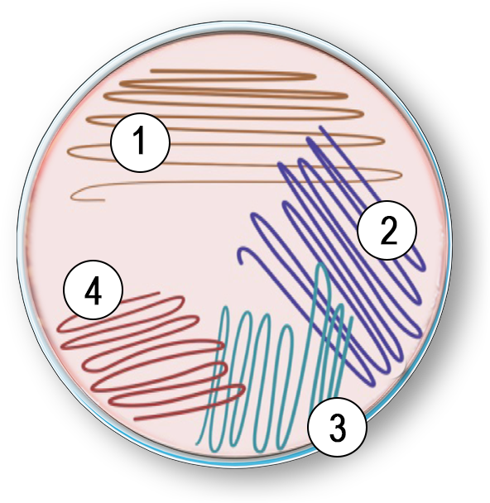Inoculate the new plate by placing a drop of specimen/bacterial growth on the first quadrant. If you received a swab specimen, touch the swab to the first quadrant.
6. Make a 1-inch streak down the first quadrant from the outside edge, then streak back and forth across this inoculum.
7. Rotate the plate a quarter turn.
8. Use a sterile loop to streak the second quadrant by touching the edge of the first quadrant about four times, then continue streaking the second quadrant without going back into the first quadrant.
9. Rotate the plate another quarter turn.
10. Use a sterile loop and repeat the process above but only go into the second quadrant two or three times and complete the third quadrant streak.
11. Turn the plate another quarter turn.
12. Use a sterile loop and streak the fourth quadrant the same as the third but let streaks get smaller and trail off.
13. Replace the lid on the plate and incubate it upside down (to decrease condensation) according to your laboratory’s testing protocol.

**Tip:** Good aseptic techniques suggest using a new sterile loop or resterilizing a metal loop after each quadrant streaking especially as a beginner.