Quadrant Streaking for Isolation

Introduction

Quadrant streaking an agar plate is performed to obtain isolated colonies from a specimen. Isolated colonies are achieved by performing a four-quadrant streak which results in a dilution of the inoculum from one quadrant to the next. Typically, by the third or fourth quadrant isolated colonies are present and are used for further testing.

Supplies

1. Personal protective equipment

2. Specimen to be streaked

3. 1.0 – 10ul metal or sterile plastic loops

4. Incinerator (if using metal loops)

5. Sharps biohazard waste container

6. Labeling pen

7. Sterile agar plate

**Instructions**

1. Use appropriate PPE (gloves, laboratory coat, and face and eye protection) according to your laboratory’s procedures and safety manual.
2. Label the bottom of the agar plate.
3. 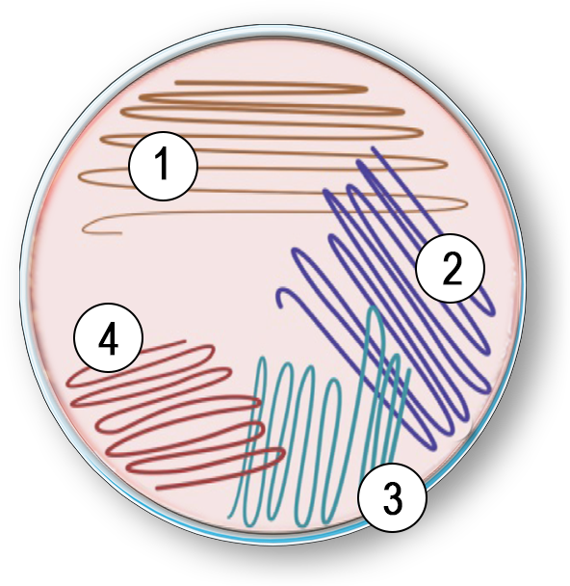Use a sterile loop to remove a small amount of bacterial growth (from broth culture or a colony from solid media). **Note:** If you are using a metal loop, sterilize it in the incinerator for 5 to 10 seconds before streaking each quadrant. Allow the loop to cool before streaking. You can make sure the loop is cool by touching an uninoculated area of the agar.
4. Inoculate the first quadrant by making an one inch streak down, then streaking back and forth across this inoculum.
5. Turn the plate a quarter turn.
6. Use a sterile loop to streak the second quadrant by going through the edge of the first quadrant approximately four times and then continue streaking the second quadrant without going back into the first quadrant again.
7. Turn the plate another quarter turn.
8. Use a sterile loop and repeat the process above but only go into the second quadrant two or three times and complete the third quadrant streak.
9. Turn the plate another quarter turn.
10. Use a sterile loop and streak the fourth quadrant the same as the third but let streaks get smaller and trail off.
11. Replace the lid on the agar plate and incubate according to your laboratory’s testing protocol.

**Tip:** Good aseptic techniques suggest using a new sterile loop or resterilizing a metal loop after each quadrant streaking especially as a beginner.