# Laboratory Symbols

Laboratory hazards are any potential sources of harm or adverse health effects in the lab. Knowing the hazards and their symbols before working in a laboratory is essential. Specific symbols identify hazards in laboratory spaces. Some of these symbols indicate animal, biological, chemical, laser, physical, radioactive, and ultraviolet light hazards.



ABSL-2 - animal biosafety level 2; experimentally infected animals housed in indoor research facilities (e.g., vivarium research facilities) and applies to the maintenance of laboratory animals that may naturally harbor zoonotic infectious agents.

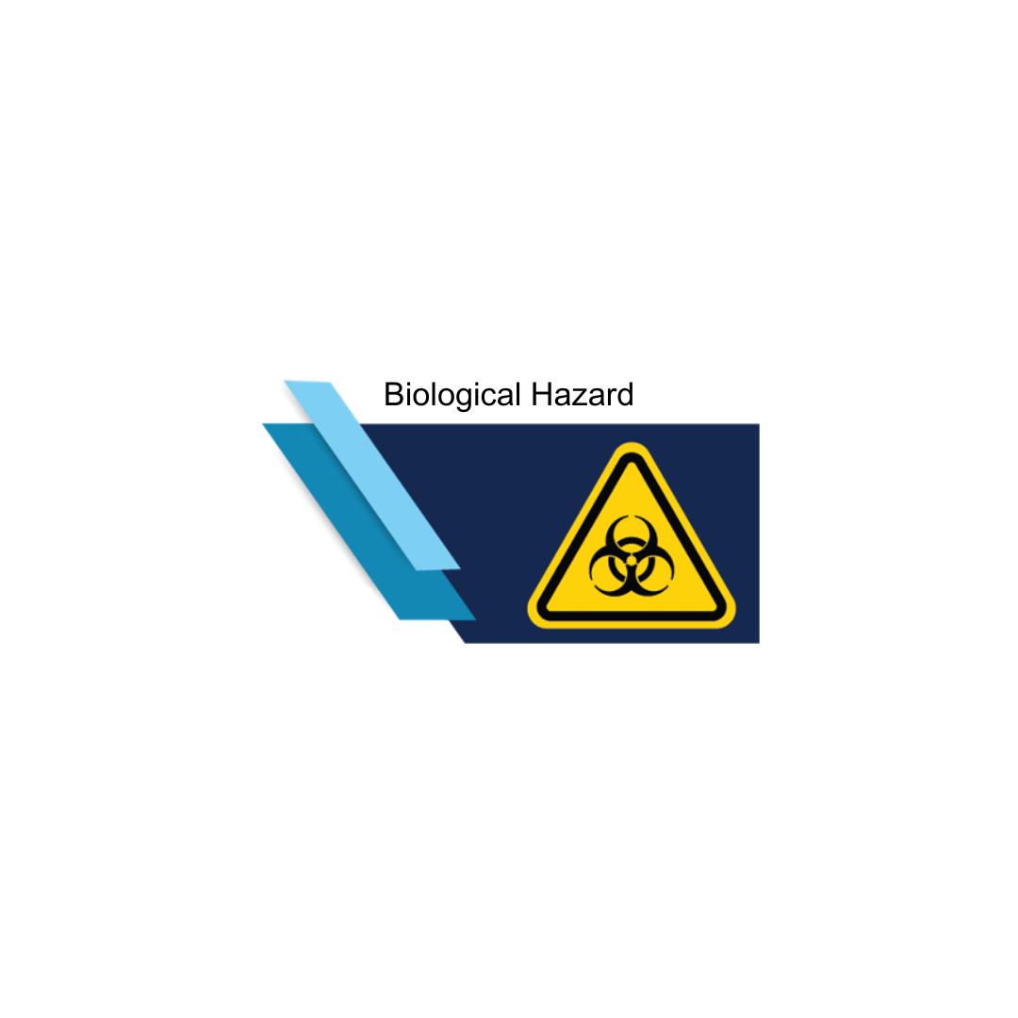

Substances that harm the health of living organisms. Specific hazards in the laboratory include human blood or bodily fluids and infectious pathogens such as SARS-CoV-2, *Staphylococcus aureus*, *Haemophilus influenzae*, and *Neisseria meningitidis*.

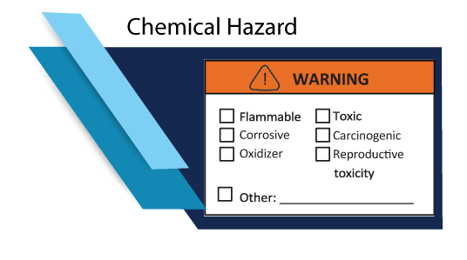

Any chemical that is a health hazard, physical hazard, and can include formaldehyde, dichloromethane, acetonitrile, hydrochloric acid, methanol, and many disinfectants. E.g., Any chemical that can indicate different hazard types, such as health risks, flammability, and environmental risks.

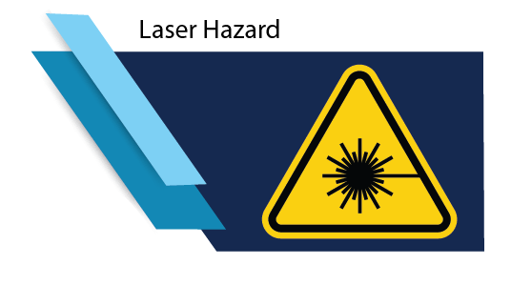

Hazards result from the presence of lasers in the laboratory such as in industrial lasers and medical device lasers. Exposure to lasers can damage the eyes and skin. Lasers also have the potential to start fires.

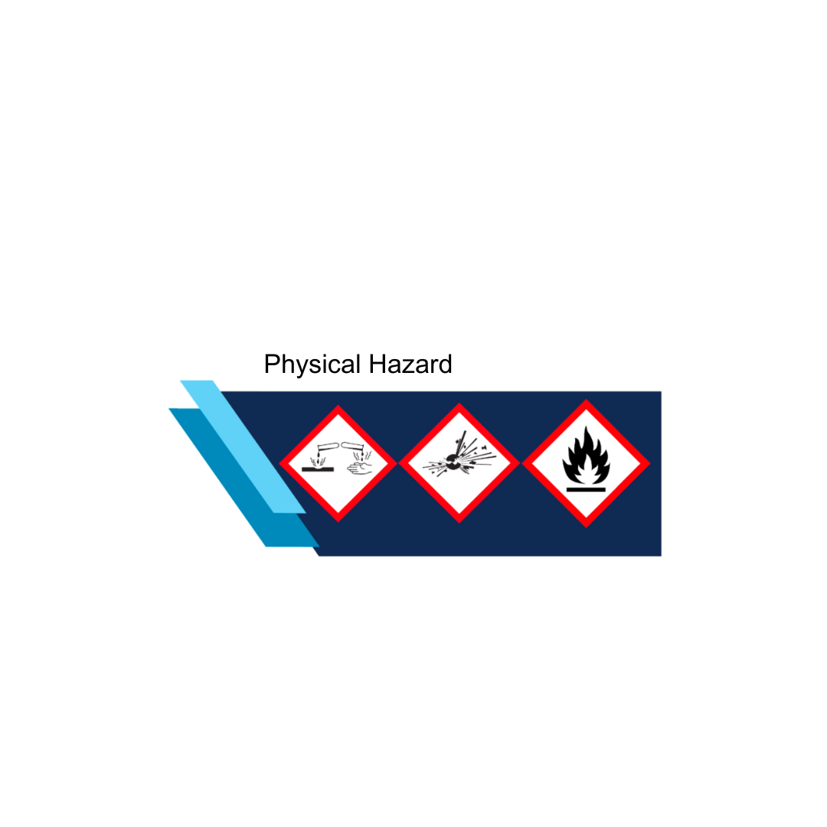

Corrosive substance - severe burns, eye damage, instant corrosion to metals. Exploding bomb - explosives, self-reactive substances, and organic peroxide that may mass explode in a fire. Flame - flammable gases, aerosols, liquids, and solids that may catch fire when in contact with air. Have a low flash point. Produce flammable gas when it comes in direct contact with water. Catch fire with concise contact with an ignition source.

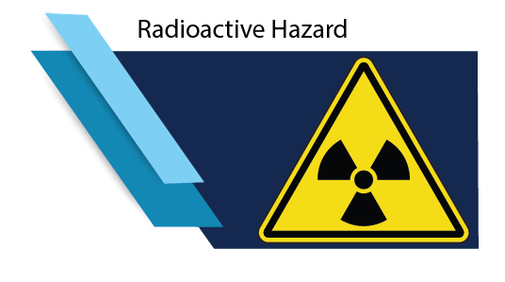

Hazards typically refer to radiation caused by unstable atoms that give off particles and energy to reach more stable states. These particles and energy cause changes in the exposed cells, specifically to the DNA molecules inside the cells.



Hazards result from the presence of ultraviolet lights in the laboratory such as in biological safety cabinets, germicidal lamps, and transilluminators. These lights can harm the skin and eyes without any initial pain, and the damage may not appear until hours later.