Hierarchy of Controls

The practical and effective method of reducing laboratory professionals’ exposure and risk of illness or injury is to use the hierarchy of controls, and all levels work together collectively. The risk control measure prioritizes eliminating or substituting hazards, followed by substituting engineering controls, administrative controls, and personal protective equipment. The aim is to proactively manage risks and promote a safe laboratory environment.

Most

Effective

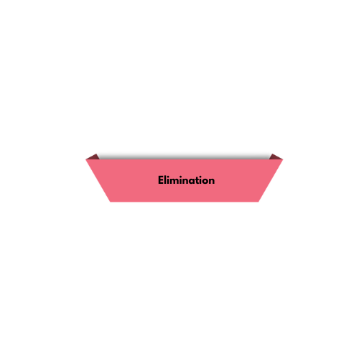

You want to physically remove the hazard using the most effective hierarchy of control.

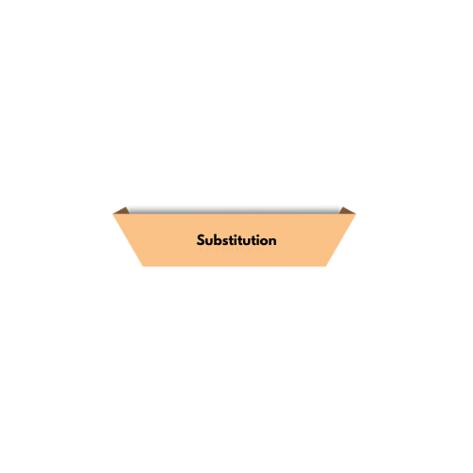Ex.: Laboratories test specimens with unknown infection types/titers, eliminating infectious organisms is not a typical option.

You want to replace the hazard with something less hazardous or nonhazardous.

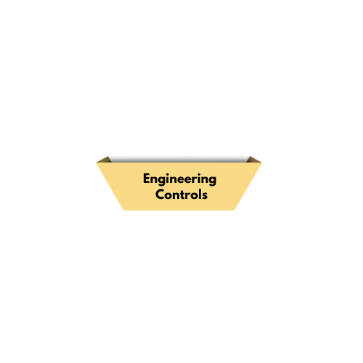Ex.: Like elimination, substitution is not a typical option.

You want to isolate people from the hazard or place a barrier between the worker and the hazard.

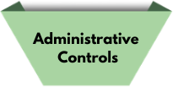Ex.: A Class II biological safety cabinet creates a barrier to reduce exposure risk by containing infectious aerosols and droplets.

You need training, written procedures, policies, and documented best practices that change how individuals work.

Ex.: Develop standard operation procedures that outline the safety and training for working with infectious organisms.

You need specialized clothing or equipment to minimize exposure to hazards.

Ex.: The last line of defense is to wear the appropriate type and fit PPE for procedures involving highly infectious organisms.

Least

Effective