**Common Disinfectants and Antiseptics**

**Note:** Use of trade names and commercial sources is for identification only and does not imply endorsement by the U.S. Department of Health and Human Services. Proprietary disinfectant products should be used in accordance with the manufacturer’s instructions for concentration, contact time, and other conditions of use.

**Disinfectants**

**Selected EPA-registered disinfectants:** A list of EPA’s registered sterilizers, tuberculocides, and antimicrobial products against certain bacteria and viruses can be found at: <https://www.epa.gov/pesticide-registration/selected-epa-registered-disinfectants>.

**Chlorine compounds** are powerful disinfectants that are inexpensive and easy to obtain. Sodium hypochlorite or household chlorine bleach solutions possess intermediate-level disinfectant properties and are commonly used to disinfect lab surfaces. For maximum potency, the working solution should be prepared fresh at the time of use or daily as needed, but studies show that weekly preparations work, too. A 10% bleach solution is also called 1/10, 1:10, or 5,000 ppm bleach solution.

**Directions for preparation:**

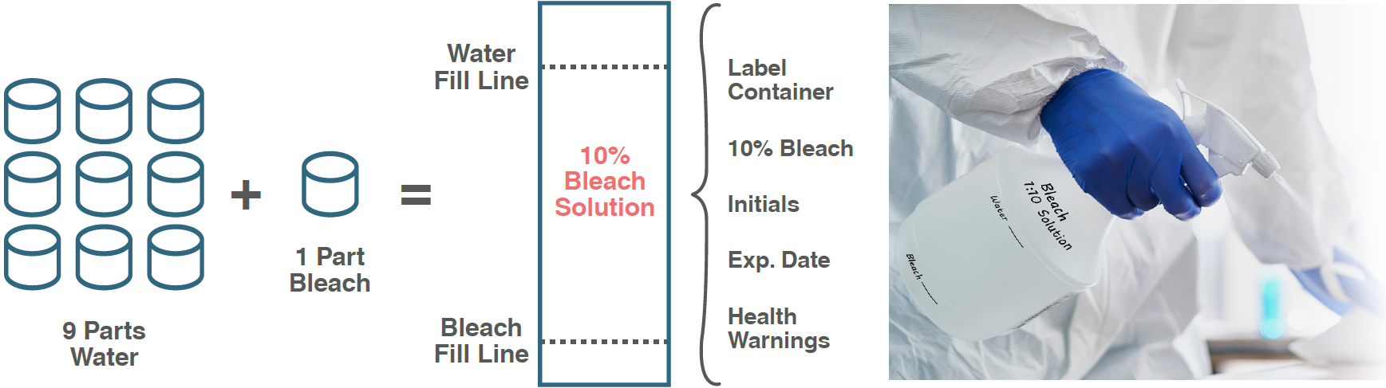

**Note:** Bleach will corrode some equipment. Refer to the manufacturer’s instructions for alternatives and recommendations for cleaning and disinfecting procedures.

**Commercial Products.** The EPA lists registered commercial products that are effective against certain bacteria and viruses. Examples are Lysol (cresol and soap solution) and Stericol (xylenol-rich cresylic acid and soap solution).

**Antiseptics**

**Alcohols** are considered intermediate-level disinfectants. Alcohol solutions are often used as a skin antiseptic. Alcohols, such as isopropyl (rubbing) alcohol, are well suited to rapidly kill bacteria on the skin surface in preparation for fingerstick or venipuncture.