**Biochemicals and Gram-Positive Organisms Identification Course Laboratory Exercises**

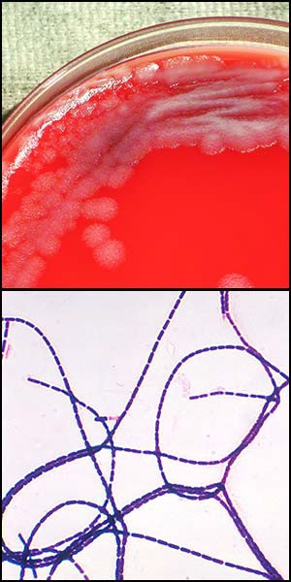After you have completed the Biochemicals and Gram-Positive Organisms ID eLearning course, it is strongly recommended that you complete the following laboratory exercises to transfer the didactic content of the course to experiential knowledge gained through hands‐on laboratory exercises with your equipment in your laboratory. Your supervisor/mentor should work with you to develop these laboratory skills as well as confirm that these exercises have been completed. The number and types of exercises you will complete will be at the discretion of your supervisor/mentor based on procedures followed within your laboratory. Included in the laboratory exercises portion of this course are the objectives of the exercises as well as the prepared exercises. After the laboratory exercises are completed and discussed with your supervisor/mentor, your supervisor/mentor should then follow‐up the exercises with instruction related to your laboratory’s specific procedures or guidelines.

### Laboratory Exercise Objectives:

After completing the Biochemicals and Gram-Positive Organisms ID laboratory exercises, you will be able to:

* Identify different types of bacterial morphology seen on a Gram stain.
* Explain commonly encountered problems with performing a Gram stain.
* Identify the different types of colonial characteristics.
* Interpret results of a tube motility test.
* Correlate results with commonly encountered problems.

Note: Be sure to review the proper use of personal protective equipment (PPE) and laboratory equipment according to your laboratory’s procedures and safety manual.

### Supply List

1. Personal protective equipment (PPE) and laboratory equipment
2. Biohazard waste container
3. Microscope and immersion oil
4. Previously prepared Gram stains for observation

### Culture Media List

1. Previously inoculated BAPs for observation
2. Previously inoculated motility tubes with or without tetrazolium chloride (TTC) for observation

Refer to Job Aids disclaimer at [reach.cdc.gov/disclaimers#ui-id-6](https://reach.cdc.gov/disclaimers#ui-id-6). This job aid is a component of the free, on-demand CDC training course “Basic Microscopy.” Find the course at reach.cdc.gov/training

**Laboratory Exercise I**

### Laboratory Exercise I

After completing this laboratory exercise, you will be able to:

* Identify different types of bacterial morphology seen on a Gram stain
* Explain commonly encountered problems with performing a Gram stain.

### Exercise: Identify Gram stain Morphology

Obtain prepared Gram stains from your supervisor/mentor.

For this exercise, you will observe Gram stains 1‐6 and identify the appropriate morphology. Next you will observe Gram stains 7‐10 and identify what is wrong with the Gram stain and explain how it might have occurred. Use the Gram Stain Cell Morphology Job Aid.

### Notes:

1.

2.

3.

4.

5.

6.

7.

8.

9.

10.

Mentor/Supervisor /Date

**Laboratory Exercise II**

### Laboratory Exercise II

After completing this laboratory exercise, you will be able to:

* Identify the different types of colonial characteristics

### Exercise: Identify Colonial Characteristics

Obtain prepared culture media plates from your supervisor/mentor.

For this exercise, you will observe the plates and identify the appropriate colonial characteristics. Use the Colonial Characteristics Job Aid.

### Notes:

1.

2.

3.

4.

5.

6.

7.

8.

9.

10.

11.

12.

13.

14.

15.

Mentor/Supervisor/Date

## Branch

**Laboratory Exercises III**

### Laboratory Exercise III

After completing this laboratory exercise, the participant will be able to:

* Interpret results of a tube motility test.
* Correlate results with commonly encountered problems.

### Exercise: Common Problems

You will examine six motility tubes given to you by your supervisor/mentor. Observe each tube for possible problems. Report the problem to your supervisor/mentor and discuss with him/her what you think may have caused the problem and what should be done to fix the problem.

### Notes:

1.

2.

3.

4.

5.

6.

________________________________

Mentor/Supervisor /Date

## raining Branch