**Shutting Down the Regulator**

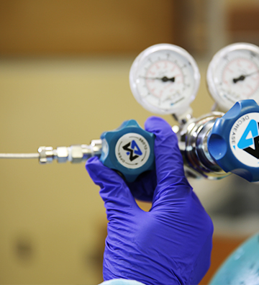

**Temporary Shutdown**

There are important safety recommendations for shutting down and removing the regulator. Temporarily shutdown your system when you will not be using it for thirty minutes or less. For temporary shutdown, simply close the regulator outlet flow valve.

**Extended Shutdown**

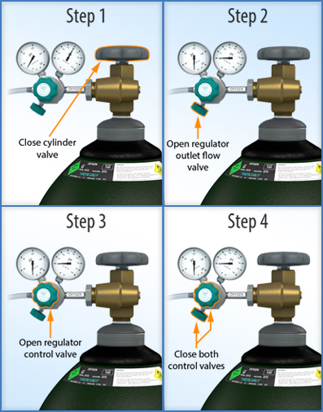When you are not using the system for a longerperiod of time (more than 30 minutes), follow the extended shutdown procedure.

For Extended Shutdown:

1. Slowly close the cylinder valve completely by hand unless a vendor supplied tool is provided. Contact your laboratory supervisor if you cannot close the valve. Shut down any additional gas supplies that may be supplying gas to the system.
2. Open the regulator outlet flow valve to drain the contents of the regulator through the system in use. Both regulator gauges should descend to zero.
3. Open the regulator control valve to release all pressure
4. Once the contents are drained, close the regulator control valve and the outlet valve.

**Note**: You must purge some hazardous gas systems into a ventilation mechanism to remove the excess gas from the laboratory. Refer to your laboratory SOP for this procedure.

Laboratory Training Branch

Center for Surveillance, Epidemiology, and Laboratory Services