**Setting the Regulator Pressure**

When opening the gas cylinder valve, position yourself so that the regulator outlet flow valve is pointing away from your body.

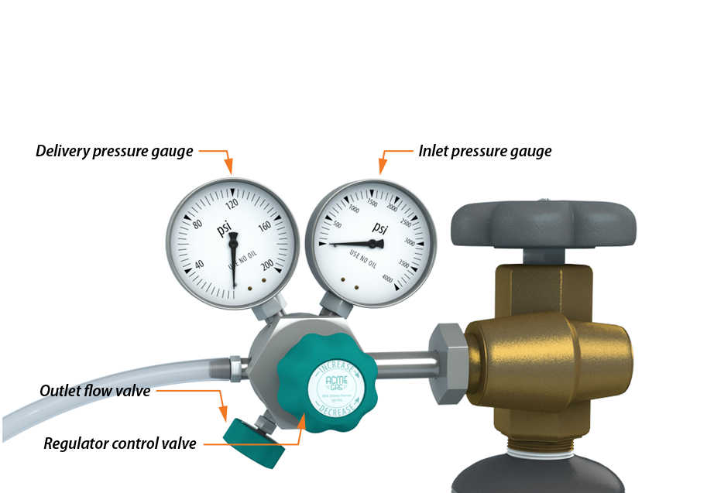Do not put your hand on top of the valve as you open it.

Slowly open the valve by hand unless a vendor supplied tool is required.

Check the inlet pressure gauge to ensure it registers the expected value.

Contact your laboratory supervisor if pressure is less than expected. Low cylinder pressure may indicate a near empty cylinder or a leaking valve which can be a serious safety issue.

Slowly turn the regulator control valve until the regulator pressure is at the desired level. Do not assume that the maximum scale reading on the gauge is the safe working pressure.

Slowly open the outlet flow valve on the regulator to start gas flow to your system. Do not use the outlet flow valve to control pressure, only gas flow. Pressure is set with the regulator control valve.

After flow is established, the set delivery pressure may decrease slightly. Check to see that the delivery pressure is as desired and make any necessary adjustments.