**Removing the Regulator**

Remove the regulator when you are finished using the compressed gas cylinder, when it is empty and you need to replace it, or before moving the cylinder.

Do not completely empty a compressed gas cylinder. Always leave at least 30 psi residual pressure. This helps prevent contamination of the gas inside the cylinder.

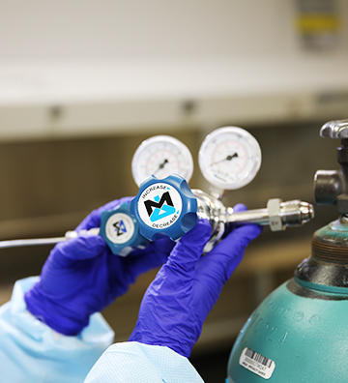To remove a regulator:

1. Follow the extended shutdown procedure.
2. Disassemble the regulator from the cylinder by slowly loosening the cylinder connection. Listen for gas seepage. If leakage is evident, re-tighten the cylinder connection immediately, and check the cylinder valve for proper closure.
3. Contact your laboratory supervisor immediately if leakage occurs when the cylinder valve is closed and the regulator has been drained of all gases.
4. Replace the cap on the cylinder over the valve stem.

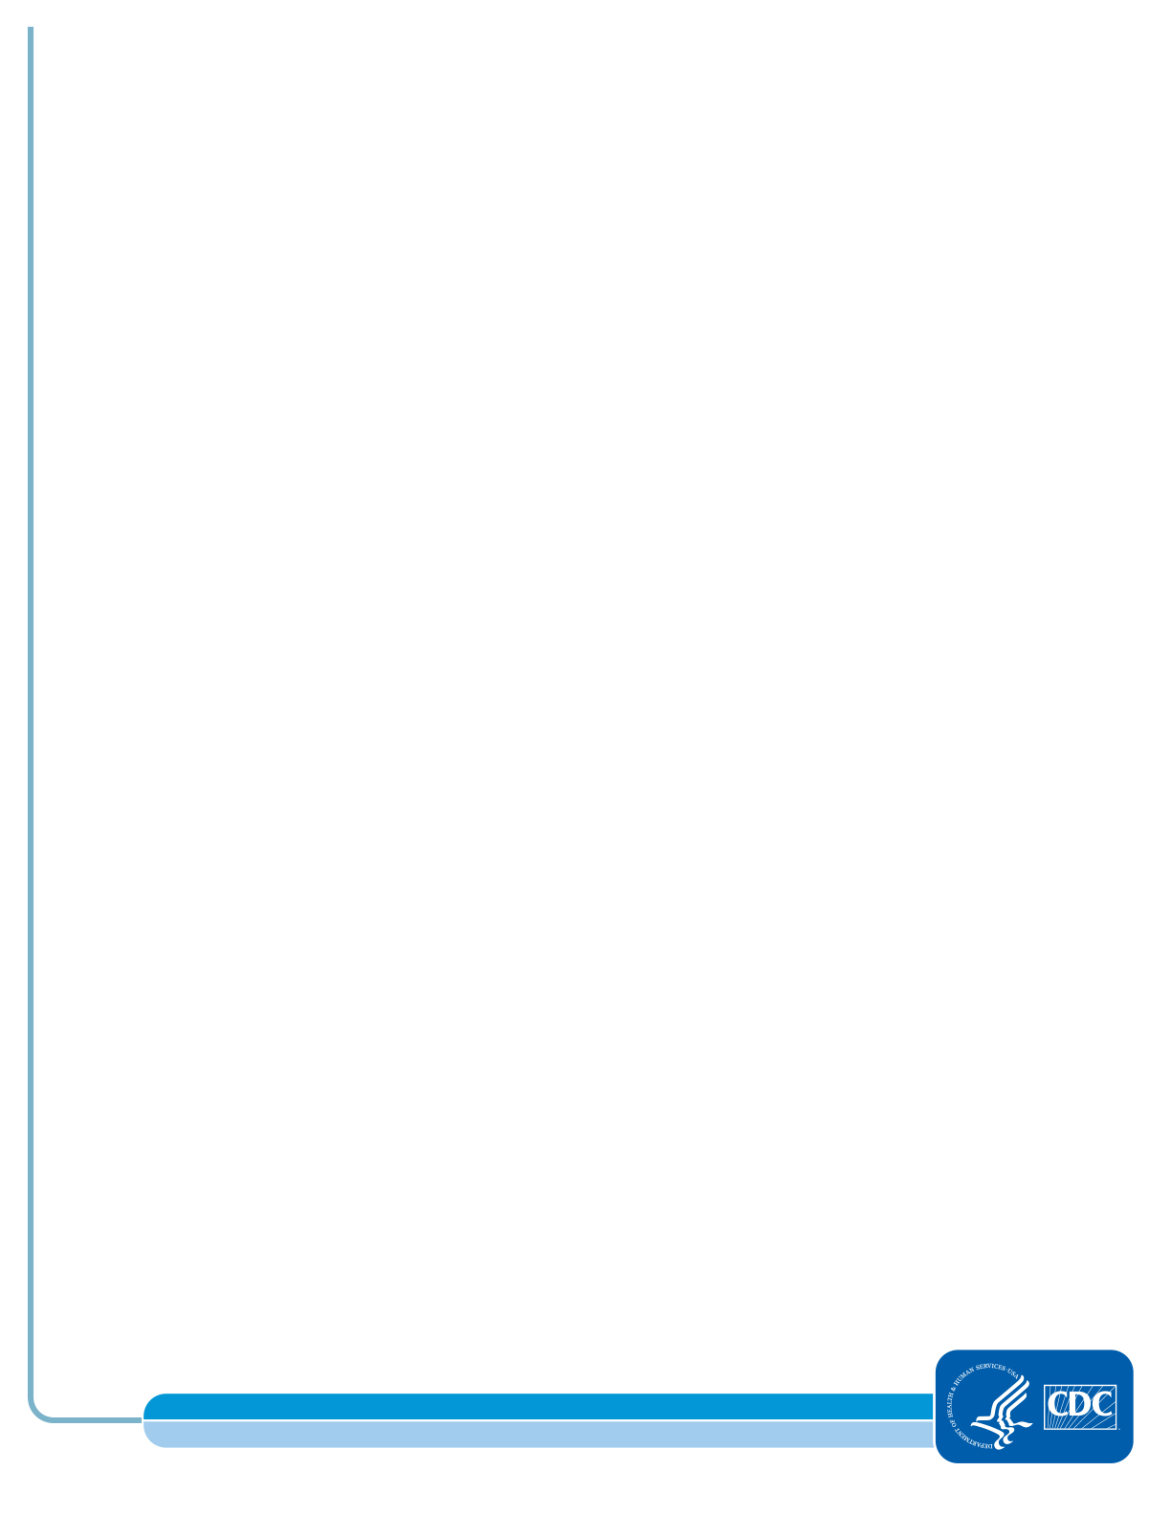

Laboratory Training Branch

Center for Surveillance, Epidemiology, and Laboratory Services