**Checking Your System for Leaks**

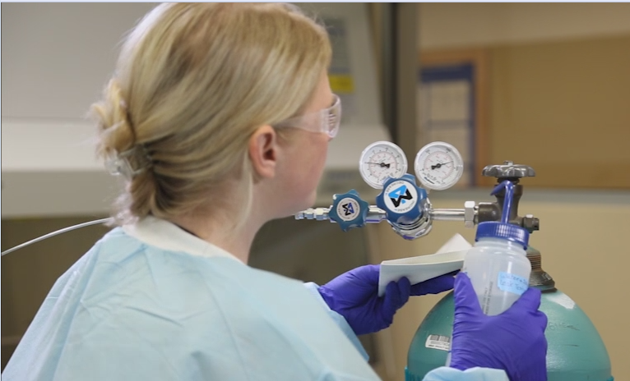Check your system under pressure for leaks prior to using the contents of the gas cylinder.

Confirm the integrity of the connection by using a bubble test or electronic leak detection instrument. Never use a flame to check for leaks.

Refer to your laboratory SOP to make sure your method and procedure is compatible with the gas being tested.

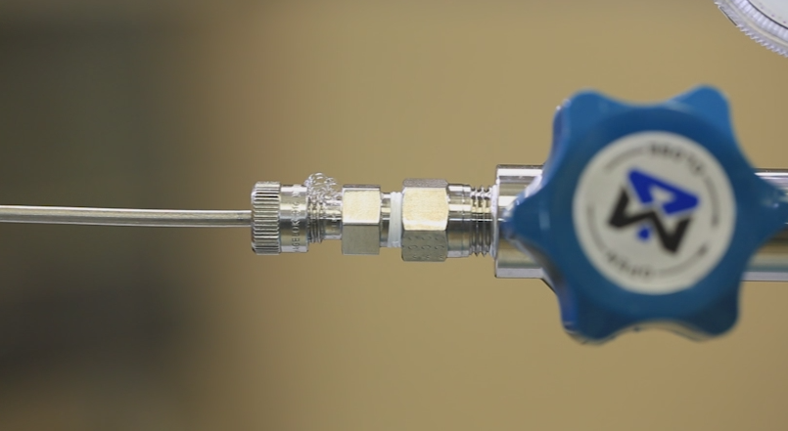A bubble test is performed with Snoop, a

compatible commercial leak test solution,

or a mild soap solution in a spray bottle.

Apply the solution to the inlet valve and outlet flow valve connections.

Active bubbles indicate a leak in your system.

Please note that soap and water may be corrosive to metal fittings.

Electronic leak detection instruments must be maintained and calibrated to ensure accuracy. Read, understand, and follow the meter’s operation manual before use.

If leaks are discovered in your system, depressurize, tighten, and then recheck the connections.

If a leak continues, notify your laboratory supervisor, and return cylinders to the gas supplier or distributor as soon as possible.

Maintain a system inspection schedule to log the cylinder leak tests. Refer to your laboratory SOP for how to keep and maintain this log.