# Calibration of the Ocular Micrometer

## Introduction

## This is a simple and precise method for measuring objects seen in the microscope. Ocular micrometers are calibrated by comparing the ocular micrometer scale with a calibrated stage micrometer. A calibration procedure must be completed to determine the calibration factor for each objective and each microscope.

## Instructions

**Step 2 – stage micrometer**

**Step 1 – ocular micrometer**

1. Insert the ocular micrometer into a 10X eyepiece. The ocular micrometer is divided into ocular divisions (OD).
2. 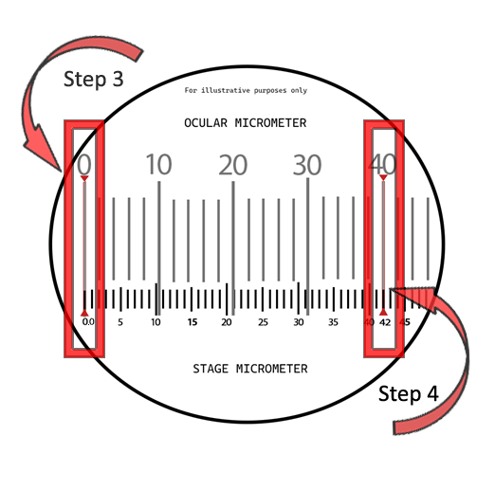Place the calibrated stage micrometer slide on the stage and focus on the scale. The stage micrometer has a calibrated scale which is divided into 0.1 millimeter (mm) and 0.01 mm units.
3. Adjust the field so the 0 (zero) line of the ocular micrometer scale is exactly superimposed upon the 0.0 line of the stage micrometer scale.
4. Without moving the stage micrometer, locate the point as far to the extreme right as possible where any two lines are exactly superimposed upon each other.
5. 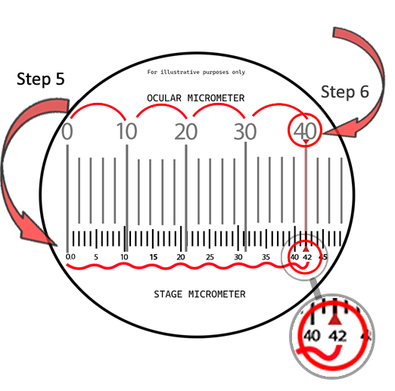Count the number of divisions on the stage micrometer between the 0.0 line and the superimposed line to the far right. In the example, the number indicated on the stage micrometer is 42 (see enlarged area).
6. Count the number of ocular divisions on the ocular micrometer between the 0 line and the superimposed line to the far right. In our example, there are 40 ocular divisions.
7. Divide the distance determined in step 5 by the number of ocular divisions in step 6 and multiply by 1000 to give the ocular micrometer units in μm. Using the values from our example, 0.042 divided by 40 equals 0.00105. 0.00105 times 1000 equals 1.05 μm.

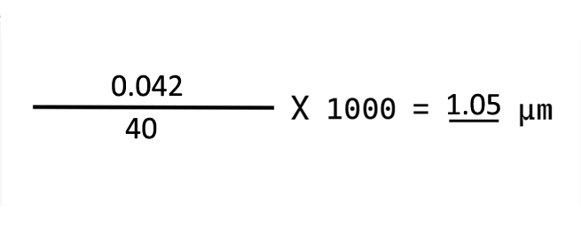

1. Repeat steps 3 through 7 for each objective on the microscope.

**Note: If at any time the ocular micrometer is moved to a different microscope or a new objective is added to the microscope, the calibration procedure must be completed again***.*