COVID-19 Point-of-Care   
Batch Testing Tips



These are general batch testing tips for a variety of COVID-19 tests. Follow the manufacturer’s instructions for batch testing.



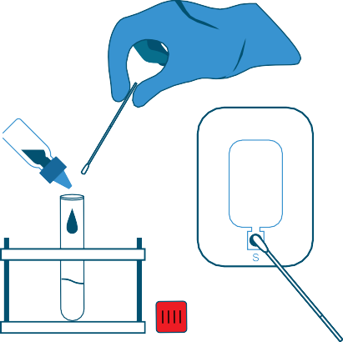

COVID-19



These are general batch testing tips for a variety of COVID-19 tests. Follow the manufacturer’s instructions for batch testing.