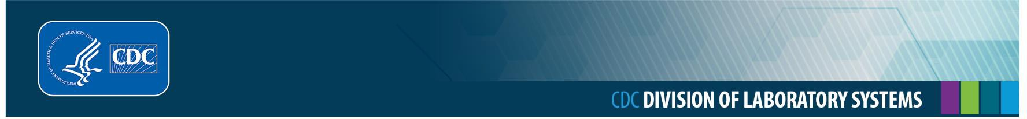

Blood and Body Fluid Exposure

It is important to use standard precautions when cleaning up blood or body fluids. **Always assume they are contaminated, and act accordingly.**

# If your hands have been exposed to blood or body fluids, follow the steps below.

1. Wet hands with warm running water.
2. Apply soap and water liberally and vigorously scrub all surfaces of hands and fingers.
3. Rinse hands thoroughly and dry with disposable towels.
4. Use a disposable towel to turn off the faucet.

Before leaving the area, decontaminate sink and faucet handles using 10% bleach or an EPA registered disinfectant that is effective against HBV, HIV, and other bloodborne pathogens.

# If mucus membranes or eyes have been exposed to blood or body fluids, follow the steps below.

1. Rinse mucus membranes (for example, nose, mouth, or eyes) with large amounts of water or saline solution.
2. If running water is not readily available, use another source of water, such as bottled water to rinse.

# If there is a puncture of skin from a sharp instrument or needle, follow the steps below.

1. Wash the puncture wound with soap and water while encouraging the puncture to bleed by gently squeezing it, if necessary.
2. Bandage the puncture when finished.

# Report exposures

1. Report any exposures to those who are responsible for managing exposures. Prompt reporting is essential, as post-exposure treatment that might be recommended, in some cases, should be started as soon as possible.
2. Discuss the possible risks of acquiring hepatitis B, hepatitis C, and HIV and the need for post- exposure treatment with the provider managing your exposure.

This job aid is a component of the free, on-demand CDC training course “Ready? Set? Test!” Find the course at https:// reach.cdc.gov/training.

v.23037