**Attaching the Regulator**

The regulator and cylinder should be inspected before laboratory use.

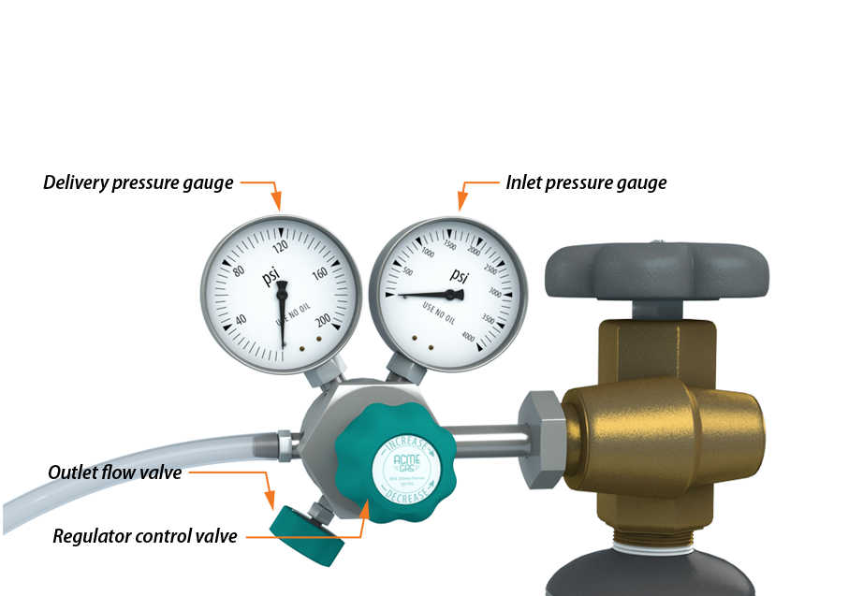

Remove the cylinder cap and ensure the cylinder valve is closed by checking for odors, visible plumes, and hissing sounds.

Check the regulator threads for damage and any grease, oil, or dust.

Close the regulator outlet flow valve by rotating the hand wheel in a clockwise direction.

Close the regulator control valve by rotating it in a counterclockwise direction.

Screw the regulator into the cylinder valve by hand until finger tight. If the regulator is not threading, do not force it. A poor fit may indicate that the regulator is not intended for use on the gas chosen.

Please note: inlet valves for flammable gases are turned counterclockwise to tighten. Inlet valves for non-flammable gases are turned clockwise to tighten.

Tighten the connection firmly using a spanner or fixed wrench. If the gas is flammable, use a spark proof wrench. Do not use pliers. Never use oil or grease on the regulator threads for oxygen regulators.