Continuity of Operations Decision Process Flowchart

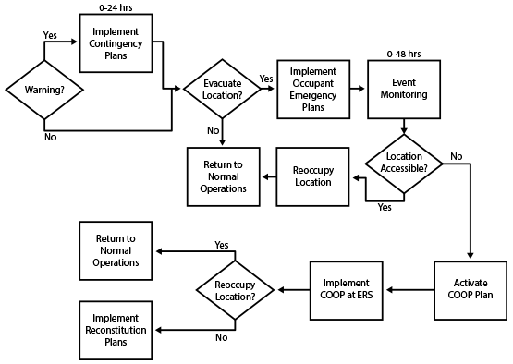

This job aid is a component of the free, on-demand CDC training course “Laboratory Continuity of Operations.” Find the course at https://reach.cdc.gov/training.

v.23143

Decision Process Flowchart Text Explanation
If there is a warning, implement the contingency plan within 24 hours.
If you must evacuate the location, implement the occupant emergency plans, and monitor the event for up to 48 hours. After monitoring, if the location is accessible, re-occupy the location, and return to normal operations. If the location is not accessible, then you should activate your COOP plan, implement the plan at ERS, and decide if relocating is possible. If relocation is possible, you should return to normal operations. If relocation is not possible, then you should implement reconstitution plans.

If there is no warning, you should evaluate whether to evacuate the location. If you do not need to evacuate, you’ll return to normal operations. If you must evacuate the location, implement the occupant emergency plans, and monitor the event for up to 48 hours. After monitoring, if the location is accessible, re-occupy the location, and return to normal operations. If the location is not accessible, then you should activate your COOP plan, implement the plan at ERS, and decide if relocating is possible. If relocation is possible, you should return to normal operations. If relocation is not possible, then you should implement reconstitution plans.

