TSI Reactions
Acid reaction (A) = yellow color Alkaline reaction (K) = red color
Hydrogen Sulfide production (H2S) = black color or precipitate Gas production (G) = bubbles, cracks, or media displacement

Reactions (slant/butt) | Symbol | Interpretation
Yellow/Yellow | A/A | Glucose in addition to lactose and/or sucrose
Yellow/Yellow with gas production | A/A, G | Glucose in addition to lactose and/or sucrose, gas produced
Yellow/Yellow with black precipitate | A/A, H2S | Glucose in addition to lactose and/or sucrose, hydrogen sulfide produced
Red/Yellow | K/A | Glucose fermentation only
Red/Yellow with gas production | K/A, G | Glucose fermentation only, gas produced
Red/Yellow with black precipitate | K/A, H2S | Glucose fermentation only, hydrogen sulfide produced
Red/Yellow with gas production and black precipitate | K/A, G, H2S | Glucose fermentation only, gas produced, hydrogen sulfide produced
Red/Red | K/K | No carbohydrate fermentation (non-fermenter)

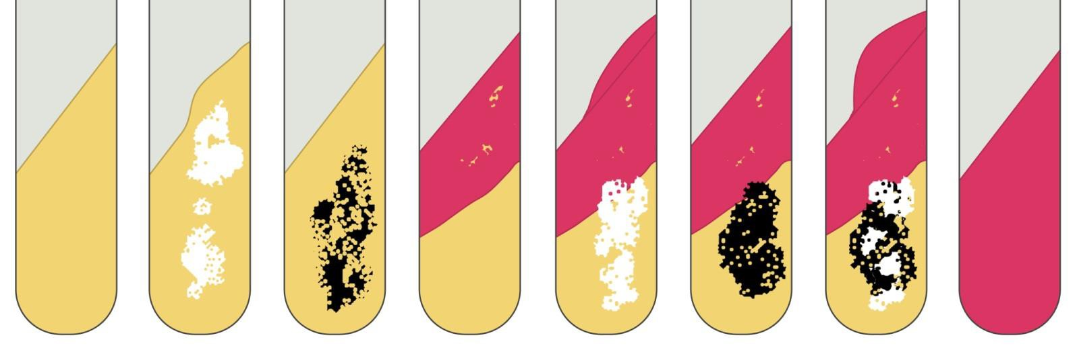

A/A | A/A | A/A | K/A | K/A | K/A | K/A | K/K
 | Gas |  |  | Gas |  | Gas
 |  | Hydrogen  Sulfide |  |  | Hydrogen  Sulfide | Hydrogen  Sulfide

