Sections of the Microscope
Introduction
Microscopy has a very important role in microbiology laboratories. A microscope is an essential tool to see microorganisms that are too small to be seen by the naked eye. In order to use your microscope effectively and efficiently in your daily routine, it is necessary that you become familiar with the major sections of the microscope.
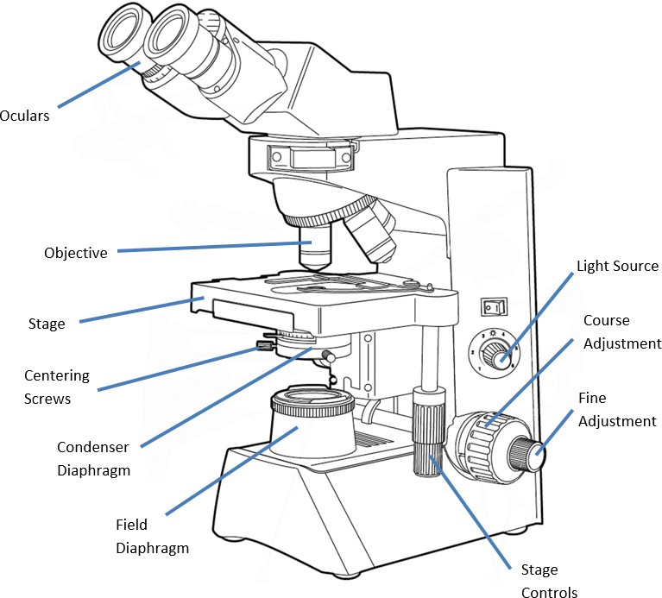
Coarse

Functions of the Microscope Sections
Condenser Diaphragm - the lens system beneath the microscope stage, positioned to concentrate light correctly on the specimen and direct the light rays into the objective. It is either a rotating disc or an iris diaphragm on the condenser used to direct the appropriate wide/slender illumination cone to the specimen and entering the objective.
Centering Screws - two screws attached to the condenser diaphragm used to center the light in Kohler illumination.
Coarse Adjustment Knob - used for rapid or rough positioning of the specimen at the focal point of the objective lens.
Field Diaphragm - an iris diaphragm, usually located on the base of the microscope that controls the amount of light that enters the condenser diaphragm.
Fine Adjustment Knob - exactly positions the specimen at the focal point of the objective lens.
Iris Diaphragm - the field and aperture diaphragms are iris diaphragms. An iris diaphragm is an adjustable assembly of thin metal leaves for varying the size of openings that determine the cross section of the light ray bundle entering the condenser and the objectives.
Light Source - usually located in the base of the microscope. It is responsible for shining light on the object on the slide.
Objectives - the lens system nearest the specimen used to magnify and direct image forming rays of the specimen to the oculars where they are further directed and magnified. Objectives are most important for determining the quality of the image produced.
Oculars - magnifying lens system of the microscope nearest to the eyes. Further enlarges the image produced by the objective.
Stage Controls - controls located underneath the stage of a microscope that allows the movement of the stage back and forth in order to allow examination of a microscope slide.

This job aid is a component of the free, on-demand CDC training course “Basic Microscopy.” Find the course at https://www.cdc.gov/labtraining.

