Routine Microscopy Procedures Student Laboratory Exercises

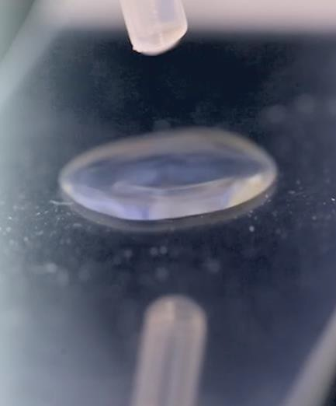Introduction
After you have completed the Basic Microscopy eLearning course, it is strongly recommended that you complete the following laboratory exercises to transfer the didactic content of the course to experiential knowledge gained through hands-on laboratory exercises with your equipment in your laboratory.
Your supervisor/mentor should work with you to develop these laboratory skills as well as confirm that these exercises have been completed. The number and types of exercises you will complete will be at the discretion of your supervisor/mentor based on procedures followed within your laboratory.
Included in the laboratory exercises portion of this course are the objectives of the exercises as well as the prepared exercises.
After the laboratory exercises are completed and discussed with your supervisor/mentor, your supervisor/mentor should then follow-up the exercises with instruction related to your laboratory’s specific procedures or guidelines.

This job aid is a component of the free, on-demand CDC training course “Routine Microscopy Procedures.” Find the course at https://www.cdc.gov/labtraining.

Student Laboratory Exercise Objectives

Laboratory Exercise Objectives:

After completing the routine microscopy procedures laboratory exercises, you will be able to:
- Outline the steps of preparing a smear.
- Express the purpose of the Gram stain procedure.
- Identify the types of reagents used in the Gram stain procedure.
- Sequence the steps in the Gram stain procedure.
- Interpret the results seen in the bacterial cells, with the effects of the various reagents during the Gram stain procedure.
- Outline the potassium hydroxide (KOH) procedure and its uses.
- Identify how to prepare and interpret a wet mount.
- Identify the steps and results obtained in the India Ink procedure.
- Identify and resolve commonly encountered problems during routine microscopy procedures.

Note: Be sure to review the proper use of personal protective equipment (PPE) and laboratory equipment
according to your laboratory’s procedures and safety manual.

Preparing for Student Laboratory Exercises

Supply List
- Personal protective equipment
- Brightfield (Compound) microscope with 10X, ,20X, 40X, and 100X objectives
- Immersion oil
- Lens paper
- Lens cleaning solution
- Microscope slides, frosted-edge
- Cover slips
- Loops (sterile plastic or metal)
- Sterile pipettes
- Slide rack
- Slide warmer or Bunsen burner (optional for heat fixing the smear)
- Absorbent paper, such as bibulous paper
- Agar plate containing isolated colonies
- Specimen or sample containing Trichomonads
- Specimen containing Yeast
- Specimen containing Clue cells
- Pencil or wax pencil
- Biohazard waste container: used for personal protective equipment, alcohol swabs and lens paper.
- Sharps container: For microscope slides if they will be discarded after the examination is completed.

Reagent List
  - Sterile saline or water
  - Methanol (optional for fixing the smear)
  - Crystal violet
  - Gram’s iodine

  - Decolorizer
  - Safranin (or carbol fuschin)
  - Potassium Hydroxide (KOH)

Student Laboratory Exercise I: Smear Preparation

Laboratory Exercise I Objective
After completing this laboratory exercise, the participant will be able to:
- Demonstrate the ability to perform a smear preparation.

Laboratory Exercise I: Making a Smear
Make a smear using the following instructions. Note: This procedure is for a culture on solid media. The procedure may slightly differ if using different specimen types.
    - Label the frosted edge of a clean microscope slide with the sample identification.
    - Using a sterile pipette, add one drop of sterile saline or sterile water to the center of the microscope slide.
    - Using a sterile loop, aseptically pick a small amount of an isolated colony.
    - Gently mix the specimen into the drop of sterile saline or water using circular motions.
    - Mix evenly to make a thin smear.
    - Allow the smear to air dry completely.
    - Fix the smear to the slide using heat fixation or methanol fixation according to your laboratory’s procedure.
    - Allow the slide to cool to room temperature or air dry.
    - The smear is ready for staining.

Notes

Student Laboratory Exercise II: Gram Stain

Laboratory Exercise II Objective
After completing this laboratory exercise, the participant will be able to:
- Utilize the Gram stain procedure to correctly perform a Gram stain.

Laboratory Exercise II: Performing a Gram Stain
- Use the fixed smear from Exercise I to perform the Gram stain.
- Place the prepared fixed smear on a slide rack then flood the slide with crystal violet.
- Wait seconds then rinse the slide with water.
- Flood the slide with Gram’s iodine.
- After seconds rinse the slide with water.
- Apply the decolorizer to the slide.
- Rinse the slide immediately with water.
- Flood the slide with counterstain.
- Wait seconds then rinse the slide with water.
- Blot the slide with absorbent paper. Be careful not to wipe the cells off the slide.
- Allow the newly stained slide to air dry completely.
- View the slide under oil using the oil immersion objective for a total magnification of 1000X.
- Record your results.

Notes

Student Laboratory Exercise III: Wet Mount

Laboratory Exercise III Objective
After completing this laboratory exercise, the participant will be able to:
- Prepare a wet mount.

Laboratory Exercise III: Making a Wet Mount
- Place a drop of a specimen on a labeled microscope slide.
- Add a coverslip.
- Observe at once using a 40X objective to observe for Trichomonads.
  - Size - about 15 µm (10-15µm)
  - Shape - round, ovoid
  - Motility - swirls, jerks and turns, seems to vibrate, undulating membrane –on one side
  - Flagella- 4 or 5, whip-like, very motile
- Record other elements seen in the wet mount such as WBCs, clue cells, squamous epithelial cells and
yeast. Quantitate based on your laboratory’s standard operating procedure.
Remember: You are able to use your Wet mount job aid for this exercise.

Notes

Student Laboratory Exercise IV: KOH Procedure

Laboratory Exercise IV Objective
After completing this laboratory exercise, the participant will be able to:
- Perform the potassium hydroxide (KOH) procedure.

Laboratory Exercise IV: Performing a KOH Procedure
- Place a drop or 10µm of a specimen on a labeled microscope slide.
- Add a drop of KOH to the specimen on the slide.
- Add a coverslip.
- Observe using the 40X objective. Look for:
  - Yeast
    - Round or oval
    - Non-motile
    - Vary in size (2-6µm)
    - Some show buds
  - Pseudohyphae
    - Filaments with rounded ends
    - Vary in length (20-100µm)
Remember: You are able to use your KOH job aid for this exercise.

Notes

