Listeria monocytogenes Identification Chart

Summary

Major pathogen found in Cerebral Spinal Fluid (CSF) and Blood only

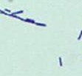
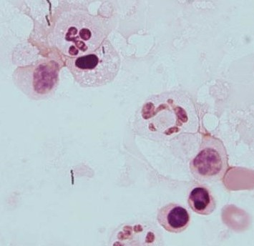
Characteristics
1.
2a.
2b.
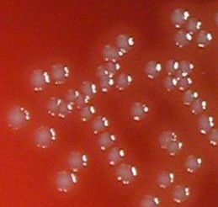
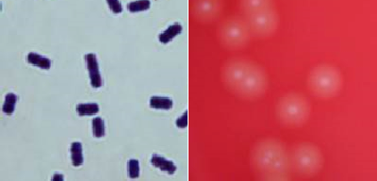
- CSF showing Polymorphonuclear leukocytes (PMNs), Monocytes, and Gram-positive rods (may be intracellular).
2c.
3a.
3b.
- (a-c)Regular small Gram (+) rods. May be short or longer.
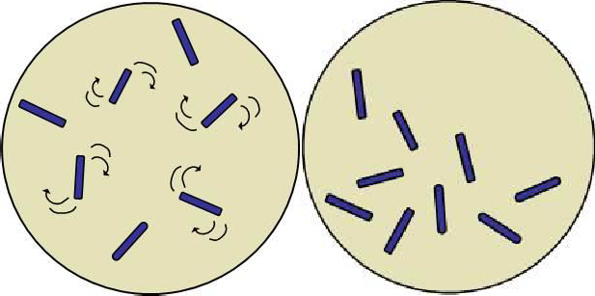
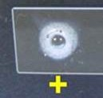
- a - Beta hemolysis does NOT extend beyond edge of colony. b – This microorganism is not Listeria because beta hemolysis extends beyond edge of colony.
4.
5a.
5b.
- Catalase (+)
Note: Colony looks like Group B streptococci. Differentiate from Group B streptococci by Gram stain and positive catalase reaction.
- Motility:
a - Tumbling motility at 26°C
b - Non-motile at 35° C
This job aid is a component of the free, on-demand CDC training course “Biochemicals and Gram-Positive Organism Identification.” Find the course at https://www.cdc.gov/labtraining.

