Laboratory Onboarding
Template

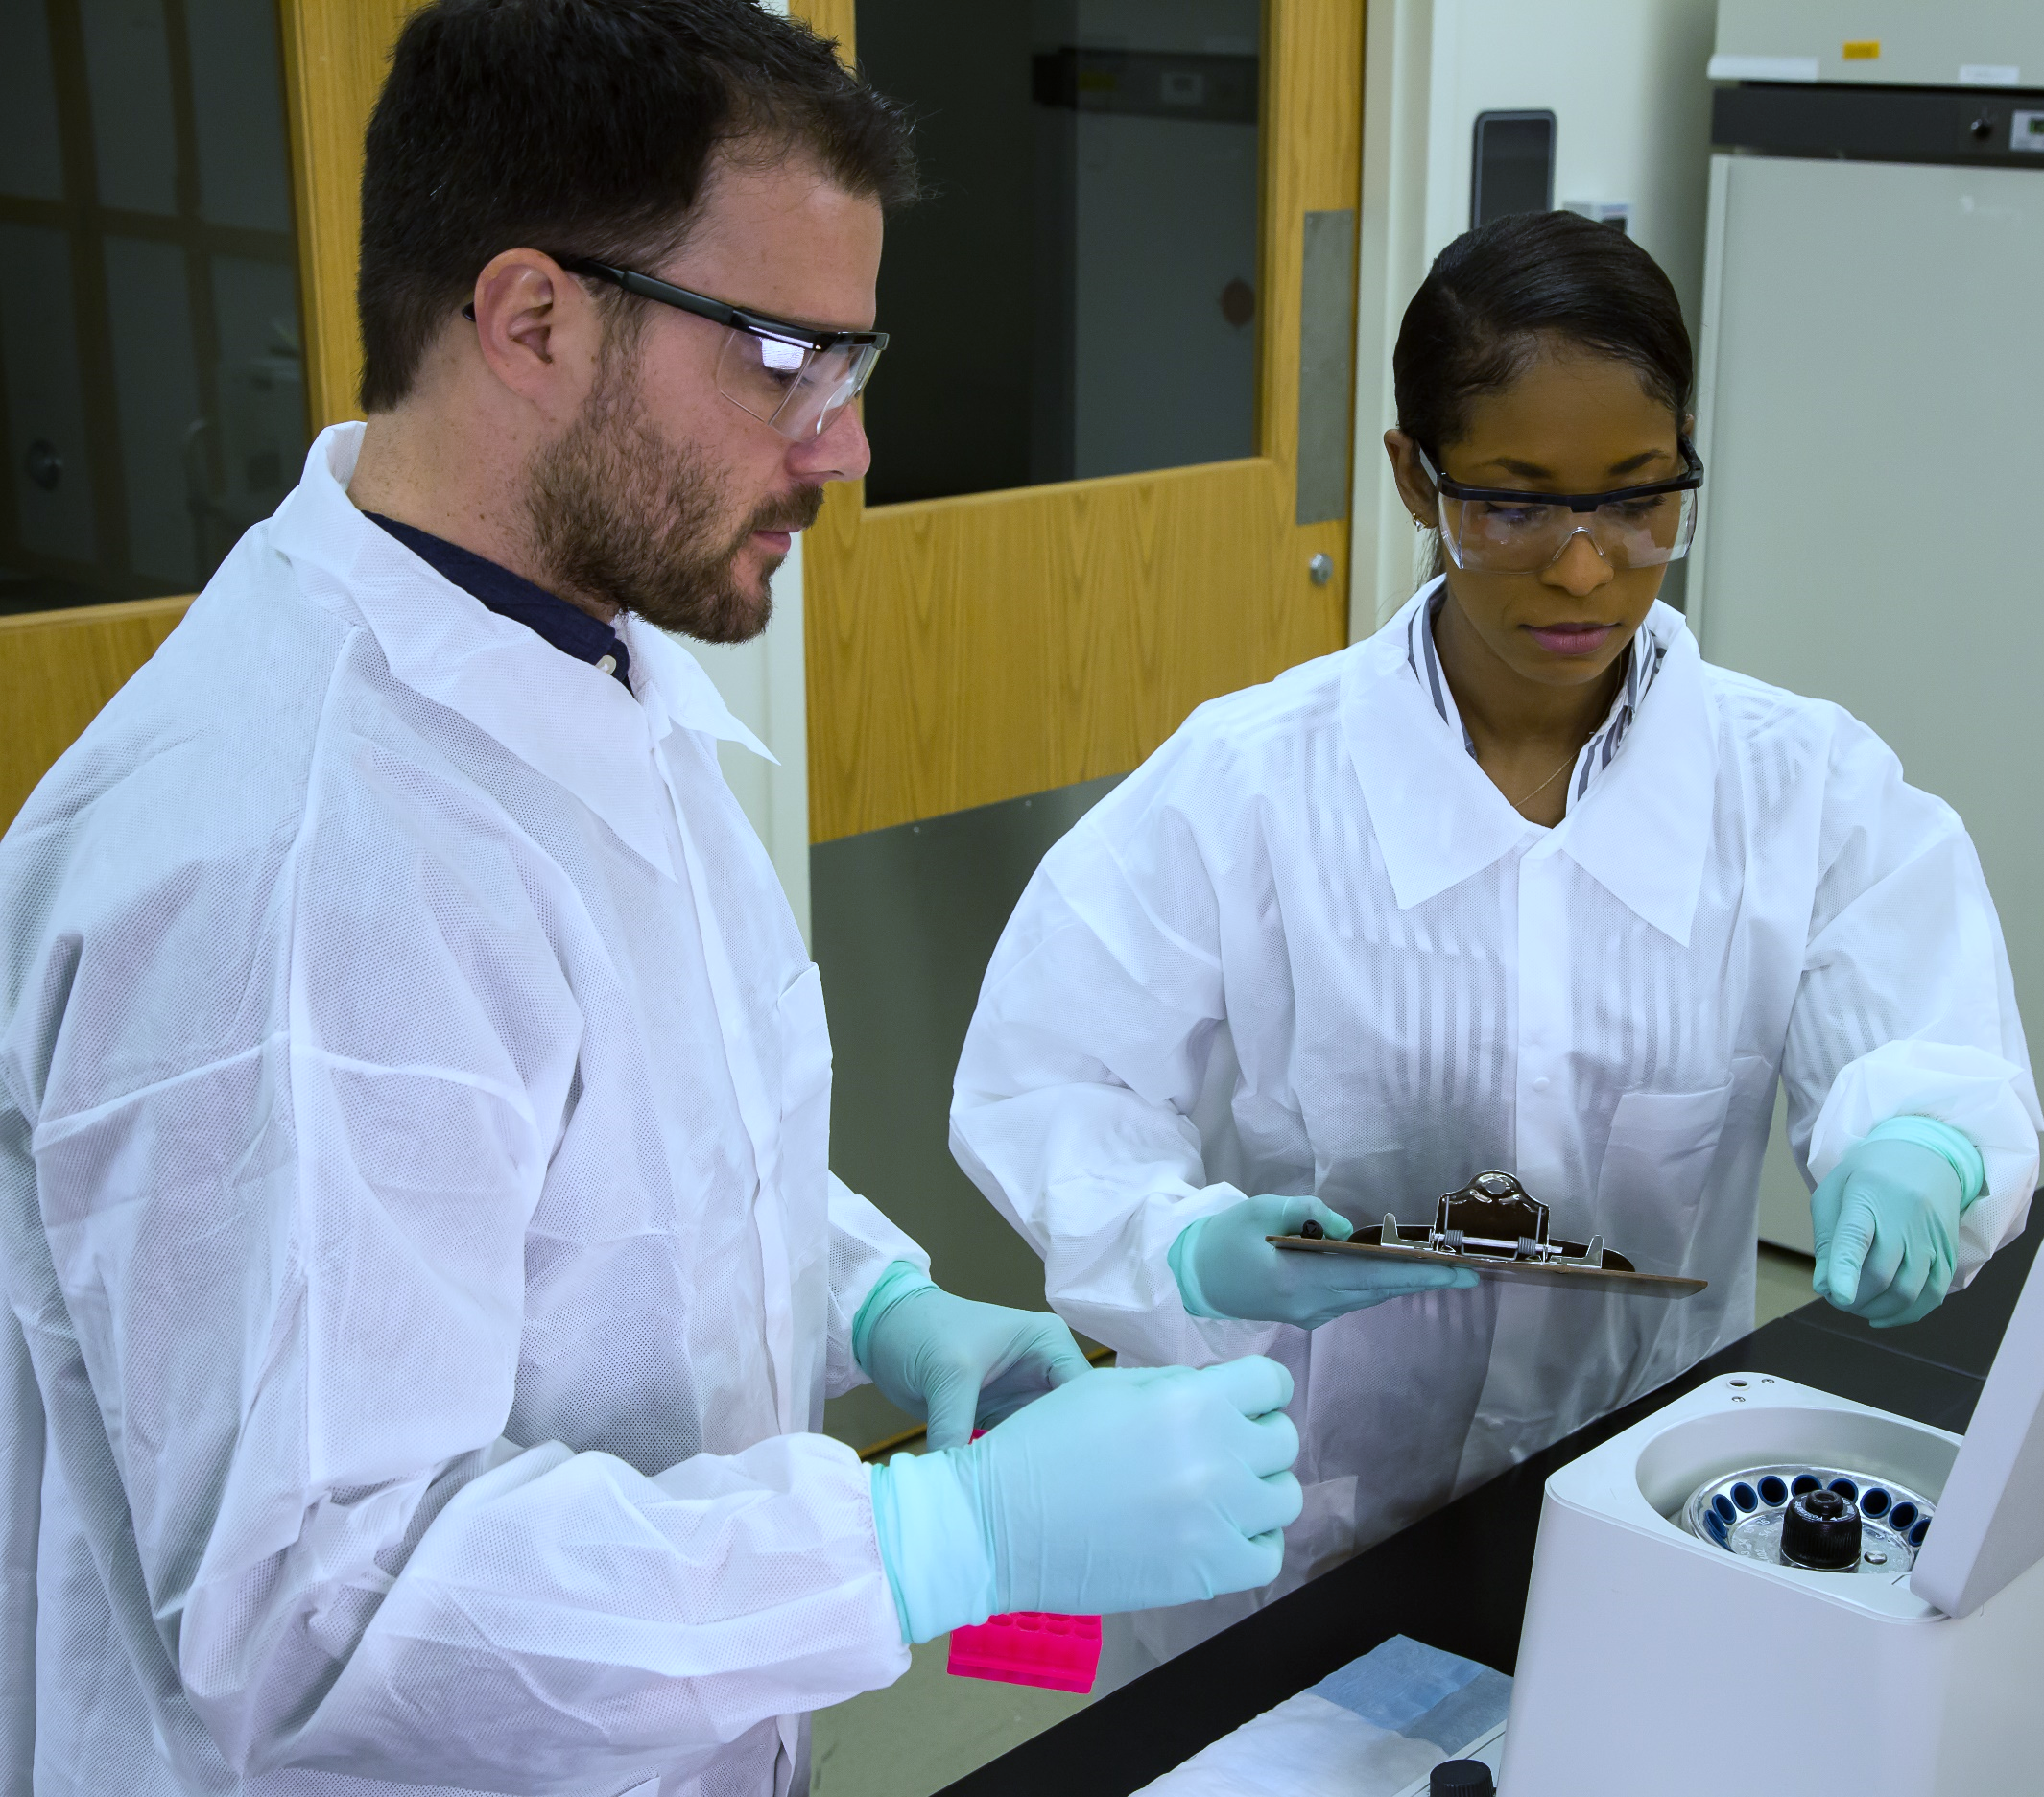

v.23047

Disclaimer
The content in this laboratory onboarding template is intended for informational purposes only. The inclusion of particular resources does not imply endorsement or recommendation by the Department of Health and Human Services (HHS) and the Centers for Disease Control and Prevention (CDC).

CDC is not responsible for any errors or omissions that may occur by individuals using this template. Each laboratory must comply with applicable federal, state, territorial, and local requirements; and ensure its onboarding manual contains the correct information specific to its laboratory’s processes and procedures. It is up to each laboratory to determine how often this document should be updated; best practices should be on a predetermined regular basis, such as annually.

Table of Contents
Table of Contents 3
How to Use this Template 4
Introduction 4
Understanding the Laboratory Environment 4
Position Details 6
Training Resources 7
Standard Operating Procedures (SOPs) 7
Contact Information 7
Document Revision History………………………………………………………………………………………………...…… 8
Document Review and Approval……………………………………………………………………………………………… 8

How to Use this Template
Creating a standard, comprehensive onboarding document for your laboratory can help save time for both new hires and existing staff. A structured, comprehensive list of site-specific information and links to SOPs and training resources can help answer common questions and reinforce main messages from site-specific onboarding activities. You can customize this basic template to fit your laboratory by adjusting the order of sections and adding or deleting sections as appropriate. It contains section headers for basic onboarding information, including emergency and safety contacts, a section for you to add training resources to your laboratory requirements, and links to supplemental training resources and job aids. By including this template with your onboarding package, new hires will have a central resource to access vital laboratory-related information and to address frequently asked questions. In addition, your customized template will save time and ensure consistency as you onboard new staff.

Section 1: Introduction
Add text here to introduce your laboratory, describe the document’s purpose, etc.

Section 2: Understanding the Laboratory Environment

Laboratory Description
Describe your laboratory, such as the laboratory name, hours of operation, and founding year.

Our Mission
If applicable, include the mission of your laboratory, facility, or institution.

Our Vision
If applicable, include the vision for your laboratory, facility, or institution.

Organizational Chart
One simple way to create your laboratory’s organizational chart is to make a slide using presentation software. Export the slide as an image with a .jpg or .png file extension, then paste the image into this document.

Code of Conduct
If applicable, you could include the code of conduct for your laboratory.

Laboratory Dress Code
Specify applicable requirements and include any recommendations for appropriate laboratory clothing.

Security
Include information on your laboratory’s security requirements or protocols.

Laboratory Ethics Policy
If applicable, you could include the ethics policy specific to your laboratory.

Section 3: Position Details
List specific position titles, roles, responsibilities, and other pertinent information, such as desired biosafety level (BSL) experience.

Position Title
List the position title corresponding to the role the employee was hired to fill.

Position Description
Briefly describe skills and attributes that are key to success in this position and why the role is important to the organization.

Duties and Responsibilities
Describe the job-specific duties, responsibilities, and competencies based on your laboratory’s requirements for this position.

Section 4: Training Resources
Training Courses
Include training courses and resources appropriate for your laboratory such as any compliance training, courses needed for specific certifications, or other site-specific training. If some training courses are required and others are optional, consider adding subheadings to distinguish between categories. In addition to site-specific training resources, consider linking relevant online training courses created by other laboratories, laboratory professional organizations, partners, etc. To access a list of free eLearning courses created by CDC’s Division of Laboratory Systems (DLS), visit www.cdc.gov/labtraining. A schedule of upcoming free OneLab live webinars and links to slides from previous webinars is available at www.cdc.gov/onelab.

Job Aids
Job aids are short-form resources that support job performance, including checklists, videos, memory aids, and illustrated instructions that provide clear, concise information about a testing protocol, reporting procedure, or other recurring job duty. Include your laboratory’s specific job aids as well as any relevant resources created by other laboratories, laboratory professional organizations, partners, etc. To access free job aids created by DLS, including many printable resources that can be customized to fit your site’s specific needs, visit www.cdc.gov/labtraining/jobaids.html.

Section 5: Standard Operating Procedures (SOPs) and Other Important Documents
Include your laboratory’s standard operating procedures (SOPs). Please review your laboratory’s biosafety manual and chemical hygiene plan to identify possible SOPs to include here. These may include but are not limited to:

- Receiving clinical samples and documentation
- Preserving samples and isolates
- Safety precautions when handling biological samples
- Test analysis
- Disposing of biological waste products
- Chemical hygiene plan
- Biosafety manual

Section 6: Contact Information
You can include titles, names, and phone numbers for all essential facility contacts such as Chief Operation Officer, Director, Facility Safety, Security, etc.

Section 7: Document Revision History
Below is an example of a document revision table you can customize to fit your laboratory’s needs. See Section 8 for an example signature approval page.
Revision Number | Change Summary | Author Name and Title | Approved Date | Effective Date

Section 8: Document Review and Approval
Add and delete the signature fields below to fit your laboratory’s needs.

Approval Signatures

Document Author: _____________________________________ _________________
Print Name and Title Date

_____________________________________
Signature

Department Supervisor: __________________________________ _________________
Print Name and Title Date

__________________________________
Signature

Quality Reviewer: ______________________________________ _________________
Print Name and Title Date

______________________________________
Signature

Laboratory Director: ___________________________________ _________________
Print Name and Title Date

____________________________________
Signature

v.23053

