[Insert your agency information here.]

KOH Procedure

Introduction
The KOH (Potassium hydroxide) procedure is a method used to examine specimens for yeast. KOH serves as an enzymatic agent that breaks down debris in a specimen, such as epithelial cells and WBCs, to view yeast or pseudohyphae.

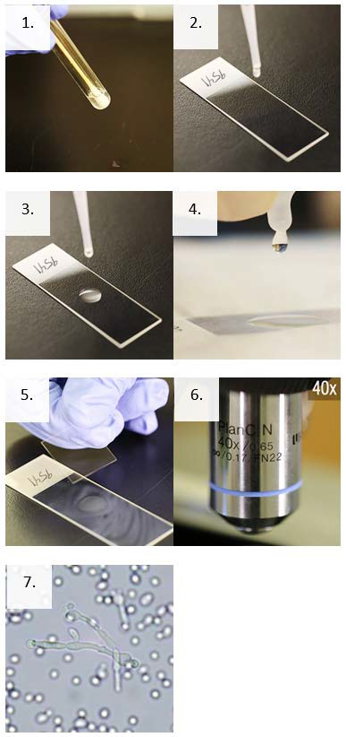

Supplies
- Personal protective equipment
- Sharps container
- Biological waste container and bag
- Sterile microscope slides
- Sterile pipettes
- Glass coverslips
- Potassium hydroxide (KOH)

Instructions
- Mix the specimen and saline solution gently.
- Transfer 10µL of specimen solution to a clean, labeled microscope slide.
- Using a clean pipette, add one drop (10µL) of 10% KOH directly to the drop of specimen on the slide.
- Hold the slide at room temperature for 5 to 30 minutes after the addition of KOH, depending on the specimen type, to allow digestion to occur.
- Place a coverslip over the slide.
- Focus the slide and scan at least 10 fields using low power(10X).
- Examine detail with higher dry power (40X).

NOTE: The slide is held at room temperature for 5 to 30 minutes after the addition of KOH, depending on the specimen type, to allow digestion to occur. Low/brief heat can sometimes be added to speed up the action of the KOH on the specimen.

