Creating a Secondary Container Label

Secondary containers must be labeled. Check your laboratory’s Chemical Hygiene Plan and SOPs and talk with your supervisor for details about how your laboratory labels secondary containers.
Below is a list of items that may be on secondary container labels in your laboratory. This list combines OSHA HazCom Standard requirements and CLIA requirements:
- Identity of the contents and concentration (titer and strength if applicable)
- Hazard(s) of each chemical (this can be expressed using pictograms or text) – obtain from Section 2 of each chemical’s SDS
- Date of preparation
- Date of expiration
- Storage requirement (if other than room temperature)

Method XYZ
Stock Solution:
Methanol 30%
Water 65%
Acetic Acid 5%
Hazards:
Highly Flammable
Toxic if swallowed, in contact with skin or if inhaled
Causes damage to organs
Causes severe skin burns and eye damage
Causes serious eye damage

Store at 10⁰C

Date Prepared: 10/4/13
Expiration Date: 12/7/14

Method XYZ
Stock Solution:
Methanol 30%
Water 65%
Acetic Acid 5%
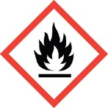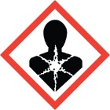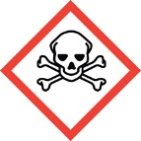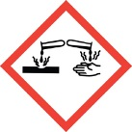
Store at 10⁰C

Date Prepared: 10/4/13
Expiration Date: 12/7/14
Laboratory Training Branch

Center for Surveillance, Epidemiology, and Laboratory Services

