Hand Hygiene Job Aid

The use of disposable gloves does not eliminate the need for cleaning your hands. Likewise, hand washing does not eliminate the need for gloves. To ensure proper hand hygiene when performing testing, hand washing or alcohol-based hand sanitizers should be used before and after each patient, just as gloves should be changed between each patient.

Hand Washing Steps
If a hand washing sink is available, follow the steps below:
- Wet your hands with warm running water.
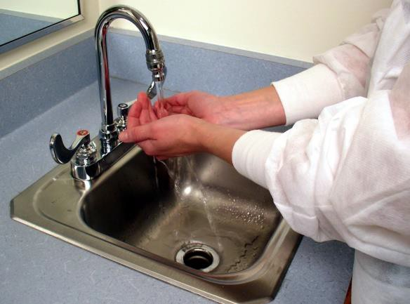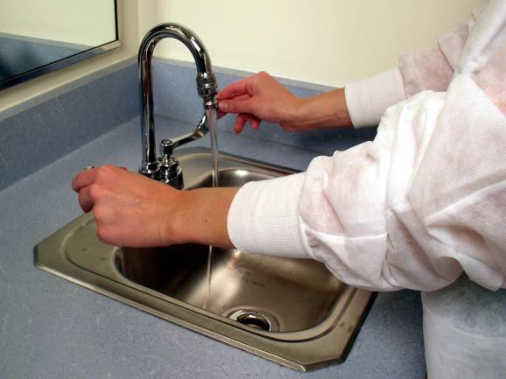

- Apply soap and rub your hands together, covering all surfaces of your hands and fingers, for at least 20 seconds.
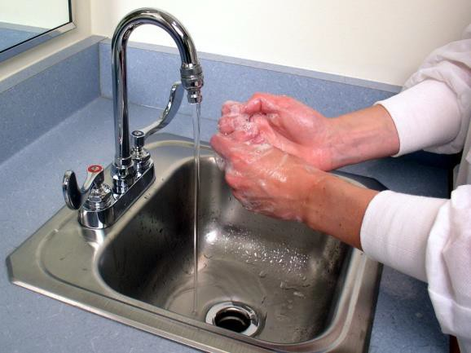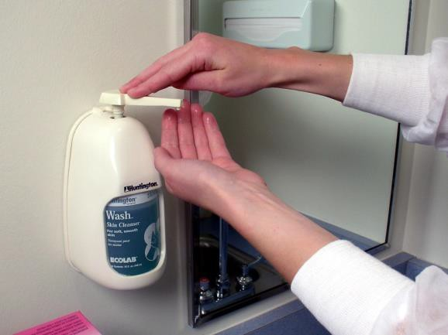

- Rinse your hands and dry them with disposable towels.
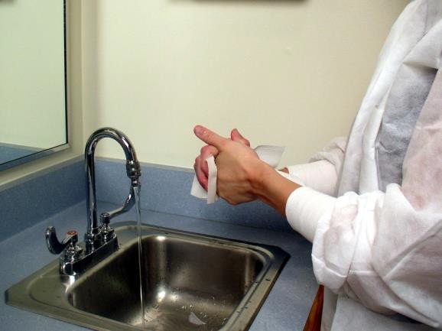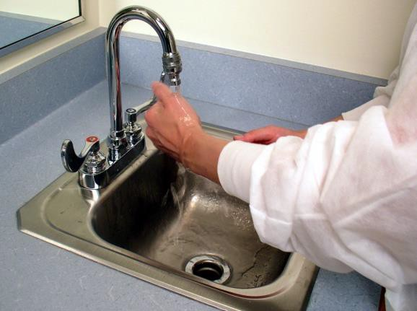

- Use a disposable towel to turn off the faucet and discard it in the regular trash.
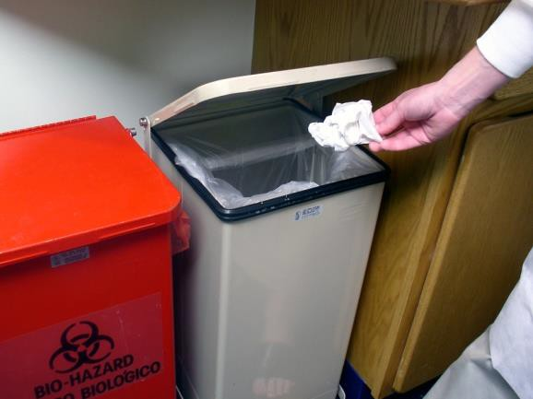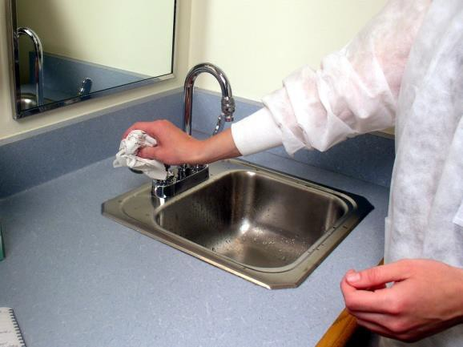

If a hand washing sink is not available, follow these steps.

- Use an alcohol-based hand sanitizer.
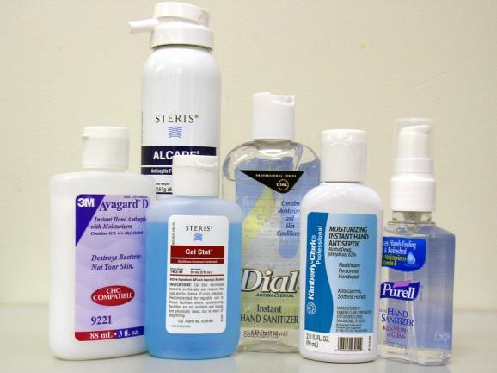

- Follow current manufacturer’s instructions to determine the amount of hand sanitizer to use.
- Apply sanitizer to palm of one hand and rub your hands together, covering all surfaces of our hands and fingers, until hands are dry.
- Wash your hands with soap and water as soon as possible.

This job aid is a component of the free, on-demand CDC training course “Ready? Set? Test!” Find the course at https://www.cdc.gov/labtraining. v.23037

