Gram Negative Rods Stool Pathogens Flowchart
* = See Biochemical Tests for Gram
Negative Organism ID Job aid for positive
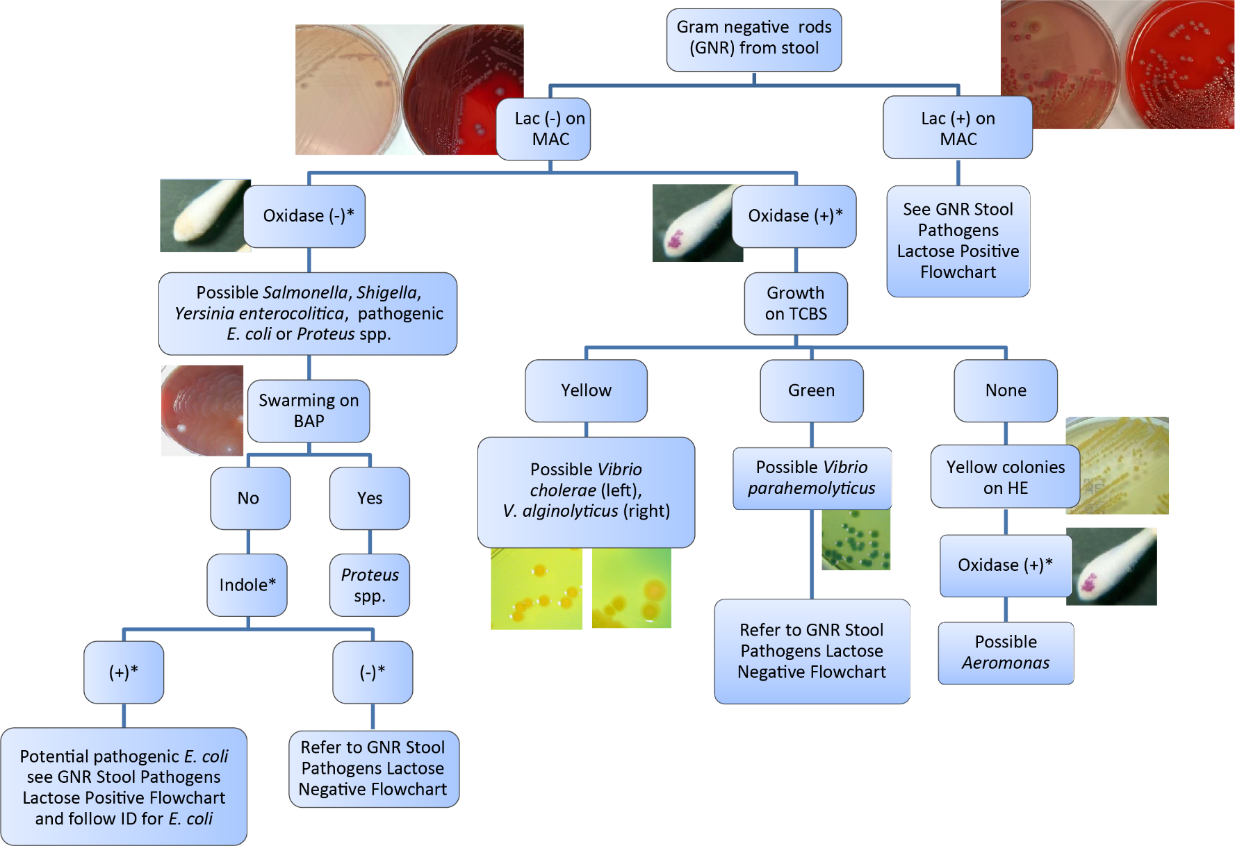
This job aid is a component of the free, on-demand CDC training course “Biochemicals and Gram Negative Organism ID.” Find the course at https://www.cdc.gov/labtraining.aboratory

