Gram Negative Rods Non-Stool Pathogens Flowchart
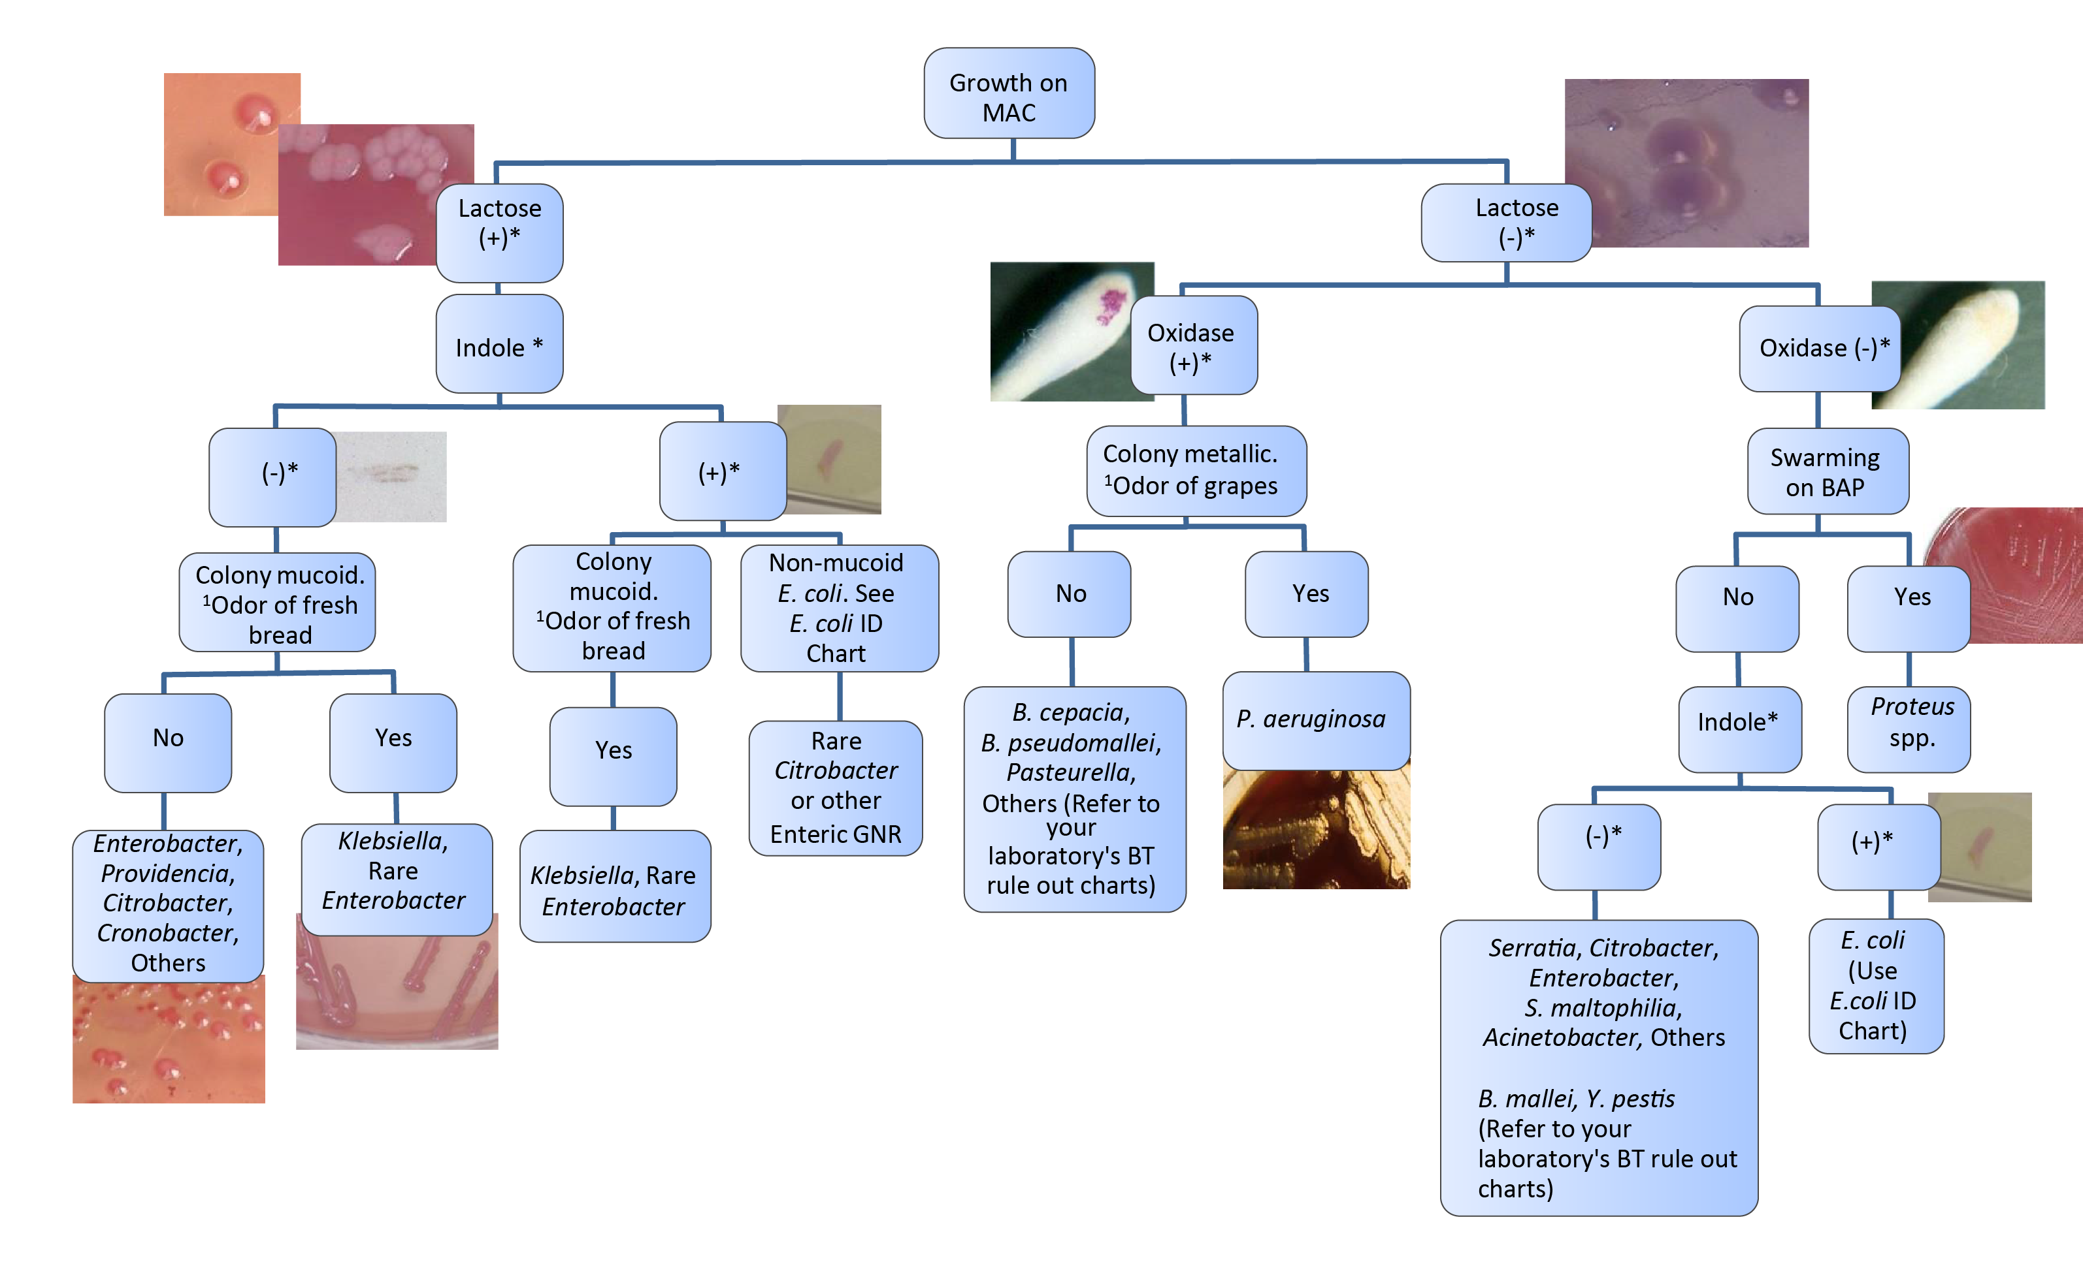

This job aid is a component of the free, on-demand CDC training course “Biochemicals and Gram Negative Organism ID.”
Find the course at https://www.cdc.gov/labtraining.aboratory
* = See Biochemical Tests for Gram Negative
Organism ID Job aid for positive and negative
result reference.

1 = Note the odor without sniffing the plate.

