Gram Stain

Introduction
The Gram stain is a differential staining procedure used to categorize bacteria as Gram-positive or Gram-negative based on the chemical and physical properties of their cell walls. The bacteria are differentiated through a series of staining and decolorization steps. Gram-positive cells will stain purple and Gram-negative cells will stain red to pink.

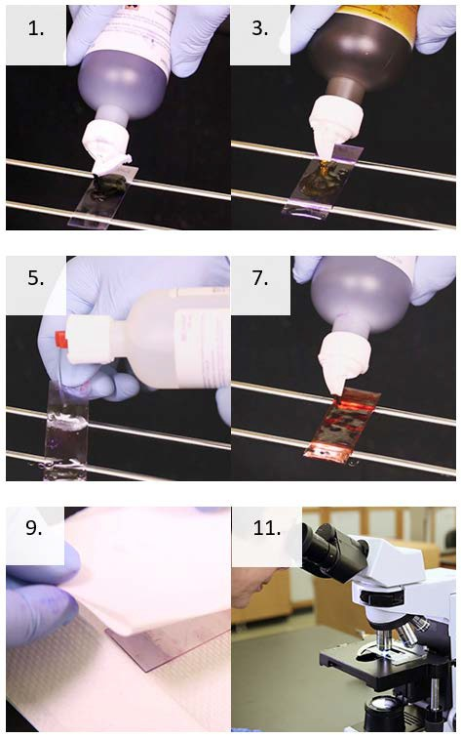
Supplies and Reagents
- Personal protective equipment
- Slide rack
- Timer
- Absorbent paper, such as bibulous paper
- Water (tap water or deionized)
- Crystal violet
- Gram’s iodine
- Decolorizer
- Safranin (or carbol fuchsin)
- Brightfield microscope with 100X objective
- Immersion oil
- Pencil

Instructions
- Place the prepared fixed smear on a slide rack then flood the slide with crystal violet.
- Wait 15 seconds then rinse the slide with water.
- Flood the slide with Gram’s iodine.
- After 15 seconds rinse the slide with water.
- Apply the decolorizer to the slide.
- Rinse the slide immediately with water.
- Flood the slide with counterstain.
- Wait 15 seconds then rinse the slide with water.
- Blot the slide with absorbent paper. Be careful not to wipe the cells off the slide.
- Allow the newly stained slide to air dry completely.
- View the slide under oil using the oil immersion objective for a total magnification of 1000X.
- Record results based on your laboratory’s criteria.

This job aid is a component of the free, on-demand CDC training course “Routine Microscopy Procedures.” Find the course at https://reach.cdc.gov
v24087

