**GNR Stool Pathogens Lactose Negative Flowchart**

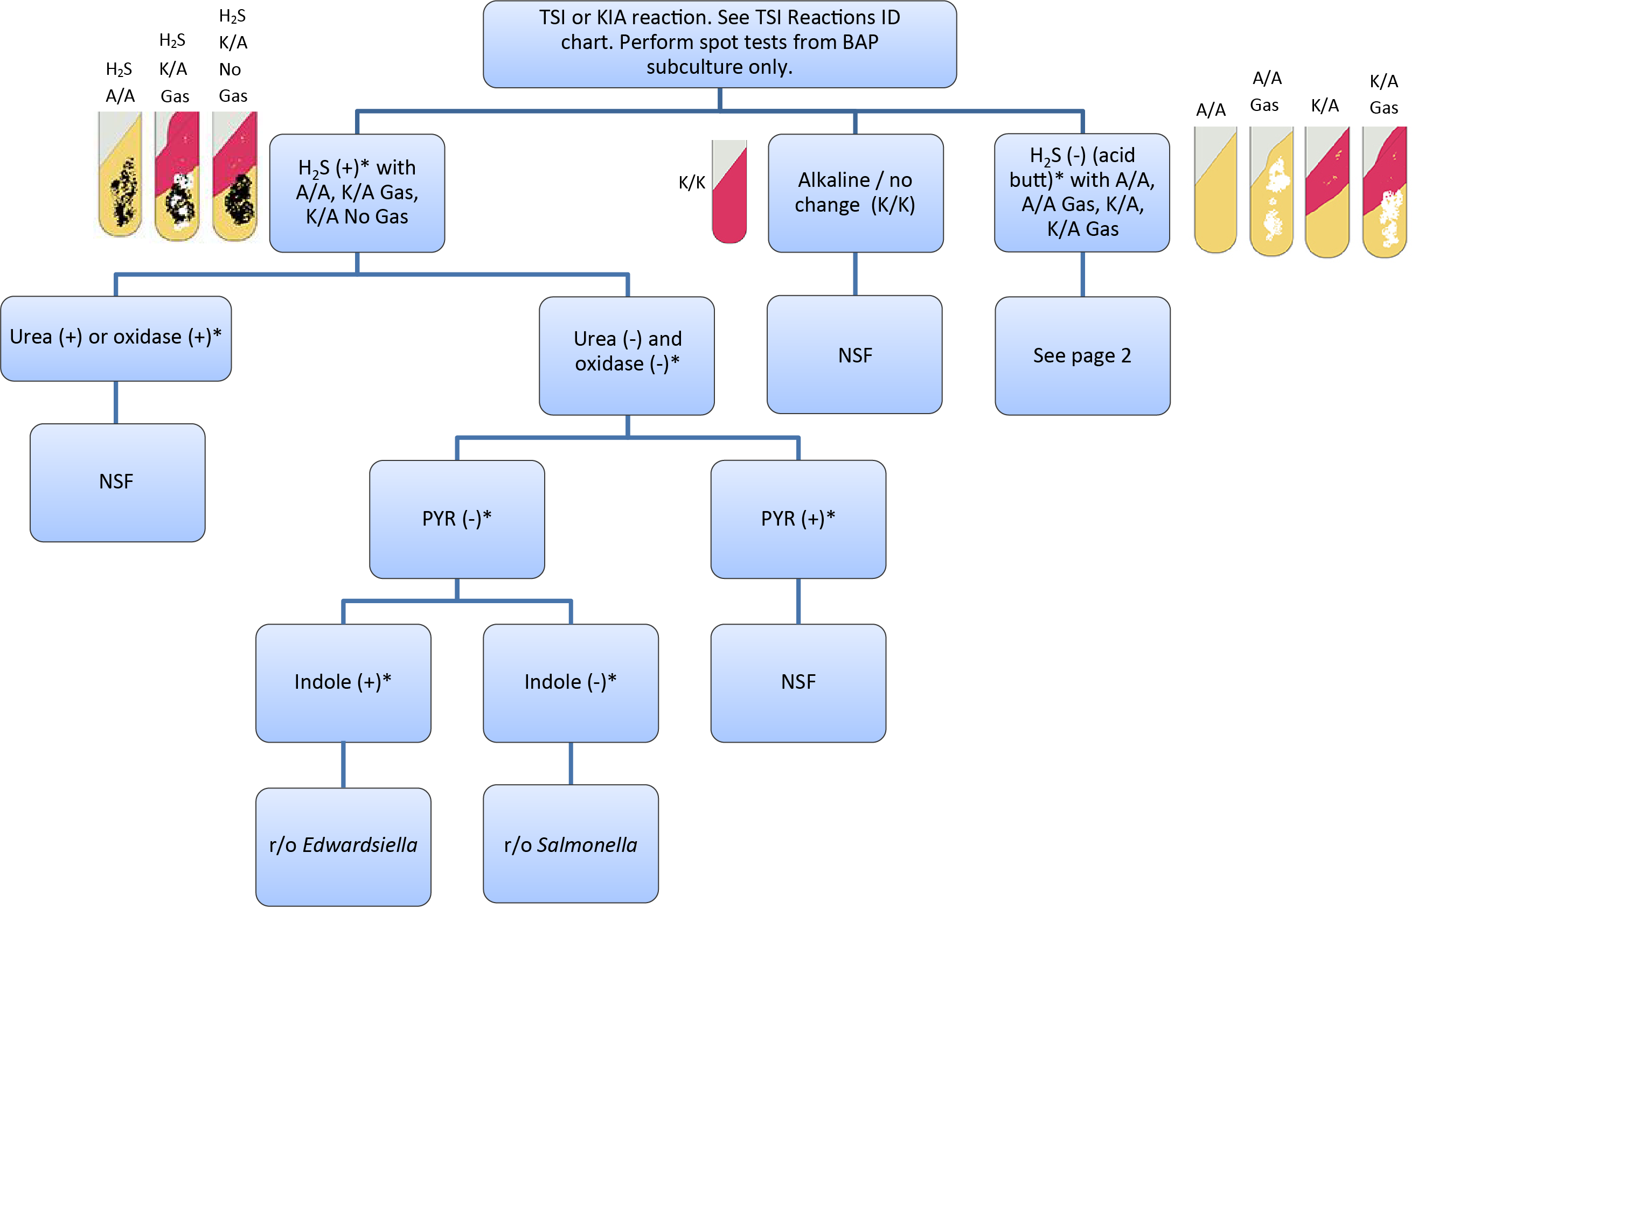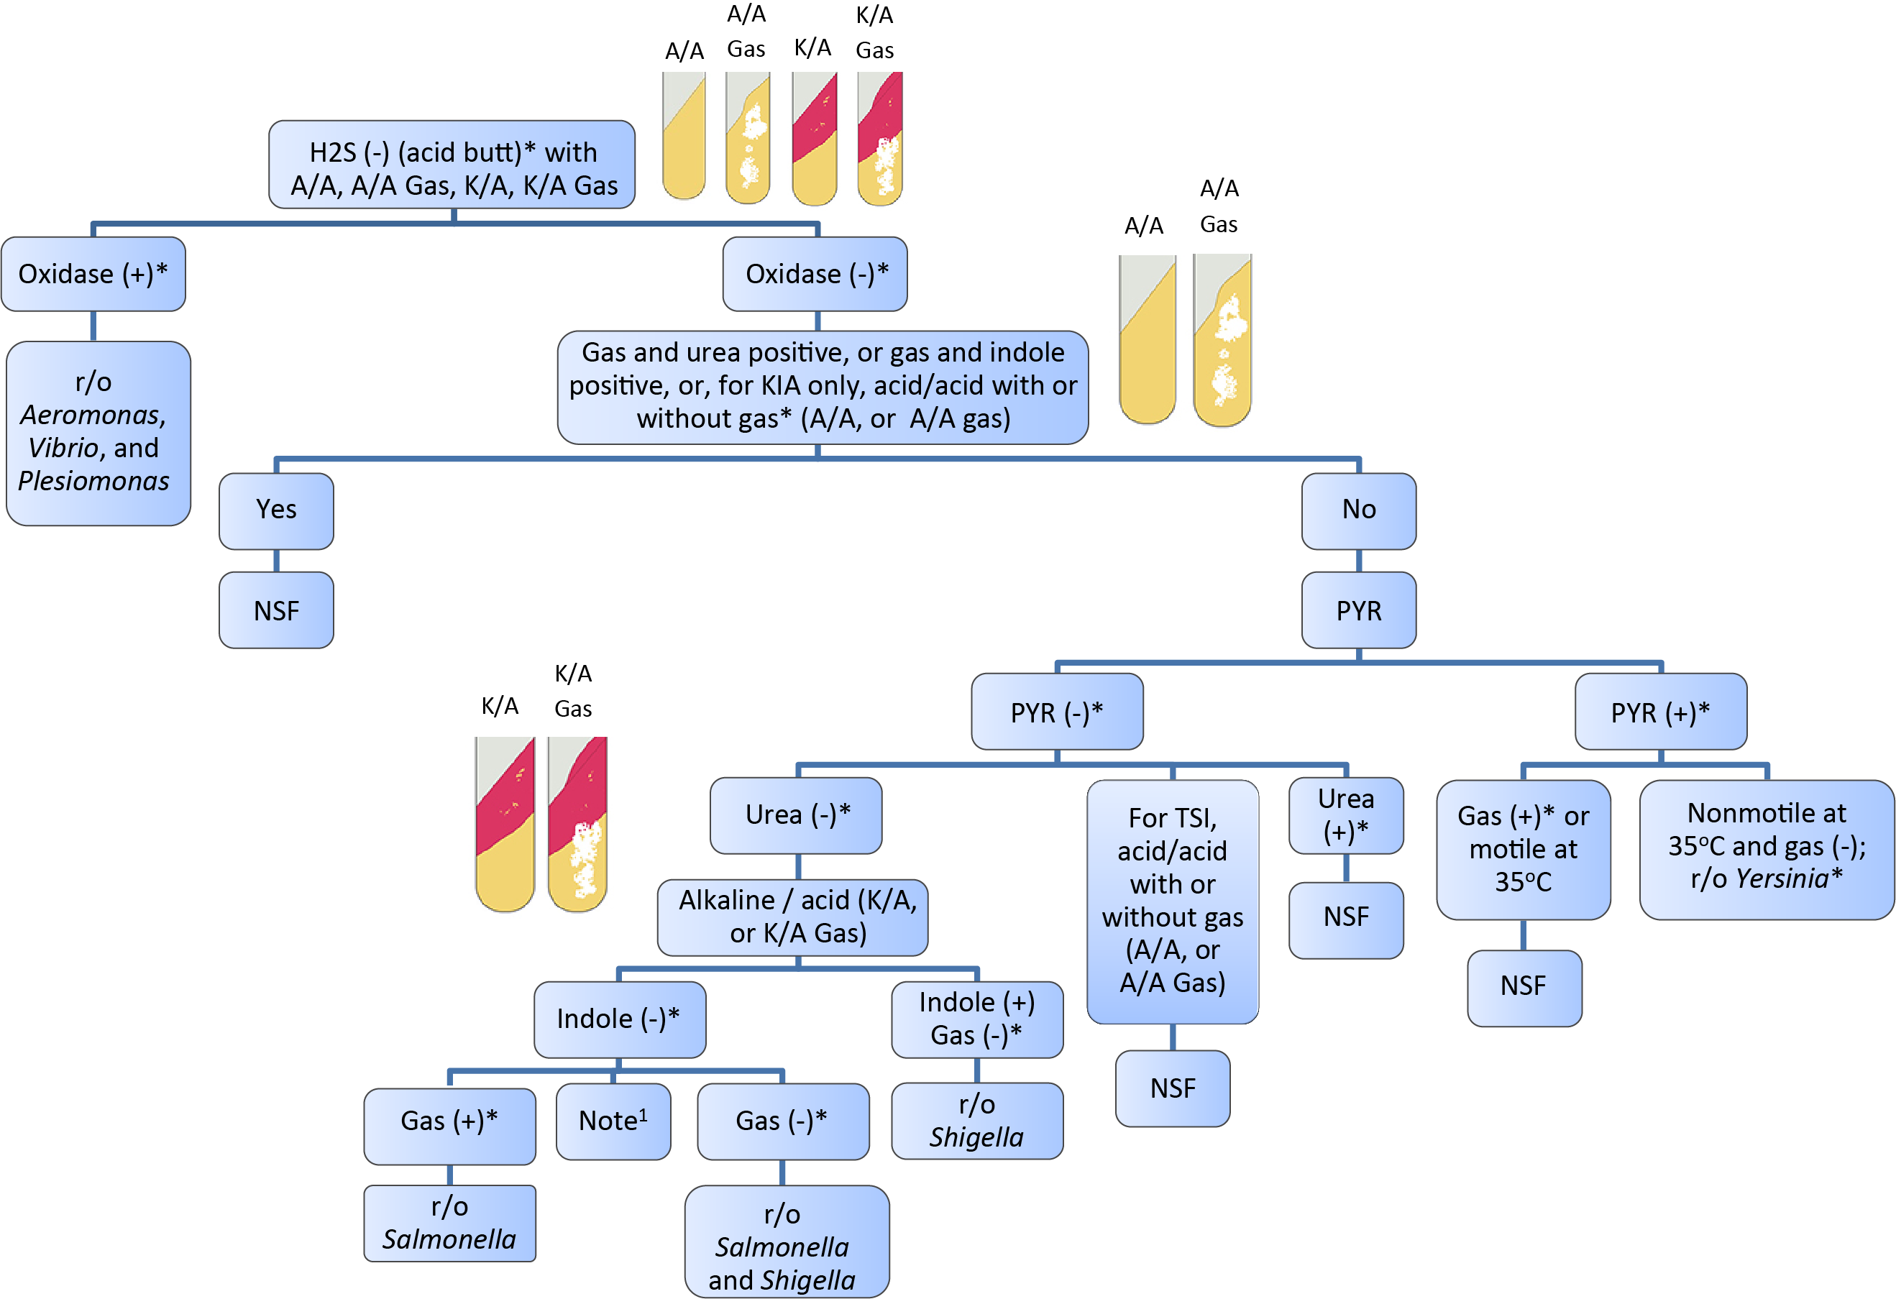

This chart is for lactose negative or H2S positive microorganisms: Aeromonas, Salmonella, Shigella,   
Vibrio, and Yersinia. Rare pathogenic E. coli may be   
lactose negative. They will produce gas in a TSI. Use   
other ID methods.

NSF = normal stool flora   
r/o = rule out

1 = Hafnia spp. can key out as Salmonella and can agglutinate with Shigella or Salmonella antisera, but it is   
VP positive at 25oC

* = See Biochemical Tests for Gram Negative Organism

ID Job aid for positive and negative result reference.