Biochemicals and Gram-Negative Organisms ID Course Facilitator Guide

Introduction
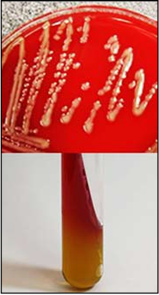
The Basic Microbiology Curriculum: Biochemicals and Gram-Negative Organisms ID Course is a blended learning activity that includes both eLearning and hands‐on laboratory exercises. Both components of the course are equally important in providing knowledge and actual laboratory experience to the participant. This facilitator guide is meant to serve as a manual for the supervisor/mentor overseeing the laboratory exercises after completing the eLearning activity. The manual contains instructions for the components of the overall laboratory exercises, objectives, laboratory setup, a supply list, laboratory exercises, instructions and answers key, and job aid.

The goal of these exercises is to allow the participant to use the information and procedures learned during the eLearning portion of the course and apply them using hands‐on laboratory exercises.
Please note: The laboratory exercises may be edited according to your laboratory’s standard operating procedures or guidelines, if necessary. The laboratory exercises were created with the forethought that laboratory procedures may vary from laboratory to laboratory and therefore, may need to be edited according to the procedures or protocols followed within that laboratory.

The participant of the course is strongly recommended to complete the laboratory exercises to transfer the didactic content of the course to experiential knowledge gained through hands‐on laboratory exercises with the equipment from their laboratory. The supervisor/mentor should work with the participant to develop the laboratory skills as well as confirm that these exercises have been completed. The number and types of exercises completed will be at the discretion of the supervisor/mentor based on procedures followed within their laboratory.
After the laboratory exercises are completed and discussed with the supervisor/mentor, the supervisor/mentor should then follow up the exercises with instructions related to your laboratory’s specific procedures or guidelines.

Biochemicals and Gram-Negative Organisms ID Course Facilitator Guide, Page 2

Laboratory Exercise Objectives
After completing the laboratory exercises, the participant will be able to:
- Demonstrate the proper technique for inoculating and incubating tubes containing triple sugar iron (TSI) agar.
- Interpret results of a triple sugar iron (TSI) test.
- Correlate results with commonly encountered problems.

Initial Planning for the Laboratory Exercises
- Communicate with the participant and schedule days/times to complete the laboratory exercises.
- Collect the supplies and culture media necessary to complete the exercises (see supply and culture media lists).
- Prepare ahead subcultures of microorganisms to be used for the TSI test.
- Label all tubes with the number corresponding to the numbers in the exercise.

Day(s) of Scheduled Laboratory Exercises
- Set up supplies and equipment for the exercises.
- Remind the participant about the use of proper PPE and laboratory equipment according to your laboratory’s procedures and safety manual.
- Pull plates and tubes out of the incubator.
- Participant should have a copy of the laboratory exercises and job aids as a printout from the eLearning course.
- Have participant complete the exercises with your approval. Please feel free to instruct participant as they work or after the exercises are completed. The exercises may be completed all at once or as time permits.
- Relay to the participant any information that is needed to comply with your laboratory’s standard operating procedures (SOPs) or safety procedures.

Supply List for Preparing the Exercises
- Personal protective equipment (PPE) and laboratory equipment
- Inoculating loops and needles (sterile plastic or metal)
- Incinerator or Bunsen burner (if using metal loops and needles)
- Labelling pen
- Test tube racks
- Biohazard waste container: for personal protective equipment (if disposable)

Biochemicals and Gram-Negative Organisms ID Course Facilitator Guide, page 3

- Sharps container: For loops and needles (if disposable)
- Incubators – CO2 and Non‐CO2

Culture Media and Microorganism List for Preparing the Exercises
- 18-hour subcultures of the microorganisms to be inoculated into tubes.
- Microorganisms:
  - Staphylococcus aureus
  - Shewanella putrefaciens
  - Pseudomonas aeruginosa ATCC 35032 or other strain that makes a lot of pyocyanin
  - Francisella philomiragia
  - Shigella spp.
  - Escherichia coli ATCC 25922
  - Salmonella Typhimurium or Enteritidis
  - Lactobacillus spp.
  - Acinetobacter spp.
  - Aeromonas hydrophila
  - Proteus mirabilis
  - Proteus vulgaris
  - Yersinia pestis A1122 (photo included on Page 9 if organism is not available)
- Culture media:
  - TSI tubes
  - Blood agar plates (BAPs)for subcultures

Supply List for the Exercises
- Personal protective equipment (PPE) and laboratory equipment
- Biohazard waste container: for personal protective equipment (if disposable)
- Inoculating needles (sterile plastic or metal)
- Incinerator or Bunsen burner (if using metal needles)
- Labelling pen
- Test tube racks
- Sharps container: For needles (if disposable)
- Incubators – CO2 and Non‐CO2

Biochemicals and Gram-Negative Organisms ID Course Facilitator Guide, page 4

Culture Media and Microorganism List for the Exercises
- Previously inoculated TSI tubes of demonstration organisms and ones that have problems (to be used for demonstration and problem solving).
- Uninoculated TSI tubes for participant practice of set‐up.
- 18-hour subcultures of the microorganisms on BAPs to be inoculated into tubes.
- Microorganisms:
  - Escherichia coli ATCC 25922
  - Shigella spp.
  - Salmonella Typhimurium or Enteritidis
  - Acinetobacter spp.
  - Aeromonas hydrophila

Biochemicals and Gram-Negative Organisms ID Course Facilitator Guide, page 5

Laboratory Exercise I

After completing this laboratory exercise, the participant will be able to:
- Demonstrate the proper technique for inoculating and incubating tubes containing triple sugar iron (TSI) agar.
- Interpret results of a triple sugar iron (TSI) test.
- Correlate results with commonly encountered problems.

Exercise
Using the microorganisms provided, inoculate TSI tubes using the proper technique. Incubate them according to the protocol and observe them at 24 and 48 hours for the correct results. Note any problems and discuss them with your mentor.
- Ask the participant to inoculate and incubate 5 tubes of TSI using the following microorganisms:
- Escherichia coli ATCC 25922
- Shigella spp.
- Salmonella Typhimurium or Enteritidis
- Acinetobacter spp.
- Aeromonas hydrophila
- Ask the participant to incubate an uninoculated tube of TSI with a loose cap in the CO2 incubator. The slant should turn yellow due to the acidity of the CO2. This will show them why you don’t incubate biochemicals that are dependent on a pH change in a CO2 incubator.
- Ask the participant to observe each tube and document the results at 24 and 48 hours. Tubes are not usually incubated longer than 24 hours because the acid reaction in the slant of lactose and sucrose fermenters may revert to an alkaline reaction.
- Ask the participant to observe each tube for possible problems.
- Ask the participant to report the problem to you and discuss with him/her what you think may have caused the problem and what should be done to fix it.

Notes:
1.
2.
3.
4.
5.
6.

Mentor/Supervisor /Date

Biochemicals and Gram-Negative Organisms ID Course Facilitator Guide, page 6

Laboratory Exercise II

After completing this laboratory exercise, the participant will be able to:
- Interpret results of a triple sugar iron (TSI) test.
- Correlate results with commonly encountered problems.

Exercise
Observe TSI tubes at 24 and 48 hours for commonly encountered problems that may arise.
- Label 20 TSI tubes with numbers 1 – 20 (do not put the names of the microorganisms on the tubes). Using the microorganisms on the list provided prepare the following TSI tubes and incubate them for 12 (Y. pestis only), 24 and 48 hours in a non‐CO2 incubator unless indicated otherwise. Include an uninoculated tube as a comparison:
- Tube demonstrating A/A with Gas: Escherichia coli ATCC 25922.
- Tube demonstrating K/A no Gas: Shigella spp.
- Tube demonstrating K/K or No Change (slant will get darker pink due to oxidation): Acinetobacter spp. Explain to the participant that anytime they see K or NC on the slant, in the butt or both, they must check for growth and make a note if they see none. Discuss why this may affect how they interpret the results.
- Tube demonstrating K/A and H2S: Salmonella Typhimurium or Enteritidis. Ask the participant to hold the tube up to a light to see the yellow in the butt. If the color is masked by H2S (you need acid to produce H2S) and the oxidase is negative, the participant should record A.
- Tube demonstrating K/A and Gas: Aeromonas hydrophila. This shows that not all glucose fermenters are enterics, an oxidase test must always be done.
- Tube demonstrating A/A and small amount H2S: Proteus vulgaris.
- Tube demonstrating K/A and H2S: Proteus mirabilis. Note how similar this looks to
Salmonella.
- Tube demonstrating weak A/K or No Change: Lactobacillus spp. – use it to show the importance of doing a Gram stain first and making sure you have a Gram-negative microorganism.
- Tube demonstrating A/No Change at 24 hours and A/A at 48 hours: Staphylococcus aureus
− again to show the importance of doing a Gram stain first.
- Tube demonstrating K/K or NC/NC and H2S: Shewanella putrefaciens – to show the importance of doing an oxidase test first. This organism is a non‐fermenter yet produces H2S without changing the color of the pH indicator, a very distinctive and key feature.

Biochemicals and Gram-Negative Organisms ID Course Facilitator Guide, page 7

Laboratory Exercise II continued
- Tube demonstrating K/A and false H2S: Pseudomonas aeruginosa ATCC 35032 or other strain that makes a lot of pyocyanin – to show the importance of doing an oxidase test first and how other factors can mimic H2S. May need to incubate it 48 hours.
- Tube demonstrating K/K or No Change and weak H2S : Francisella philomiragia – incubate for 48 hours to demonstrate what appears to be an impossible reaction in oxidase negative microorganisms. But Francisella philomiragia is oxidase positive and is a glucose oxidizer. It appears to produce H2S without the production of acid in the butt however, there has to be a pH change to make H2S even if it is not observed. So this should still be recorded as K/K or No Change and weak H2S. This again shows the need to do an oxidase test first. It is a good one for discussion. TSI slants are primarily for enterics but can be useful for identifying other Gram-negative rods.
- Tube demonstrating A/A no Gas: Shigella spp. Incubate in CO2. This will make the slant acid due to the acidic environment caused by the increased amount of CO2. Shows the importance of incubating tubes in a non‐ CO2 incubator with loose caps. Caps must be loose to allow a free exchange of air, which is necessary to enhance the alkaline condition on the slant.
- Tube demonstrating A/A no Gas: Shigella spp. Incubate in non‐CO2 with a tight cap. This will demonstrate the importance of having loose caps. If the tube is tightly closed, an acid reaction (caused solely by glucose fermentation) will also involve the slant and will not be able to revert back to alkaline once the glucose is used up.
- Tube demonstrating A/K or No Change: Escherichia coli ATCC 25922 inoculate the slant only. This cannot happen with enterics unless the tube is not inoculated correctly.
- Tube demonstrating K/A with Gas: Shigella spp. ‐ inoculate down the side of the tube to make it appear to have gas bubbles. Using a loop instead of a needle to inoculate the tube can also cause cracks in the agar that mimic gas production. Discuss what went wrong and why there should not be gas.
- Tube demonstrating K/A and questionable H2S: Salmonella Typhimurium or Enteritidis. Inoculate this tube extremely lightly. This will create only dots of H2S. TSI is not as sensitive as other methods to detect H2S, some Salmonella spp. will appear negative.
- Tube demonstrating A/A and gas and questionable H2S: Salmonella Typhimurium or Enteritidis mixed with E. coli. This will create only dots of H2S. This points out the need to make sure you have pure cultures before you start.
- Tube demonstrating K/A and questionable H2S: Shigella spp. mixed with Pseudomonas aeruginosa. This will create a dark sheen of green that looks like H2S and the tube has the correct K/A. This also points out the need to make sure you have pure cultures before you start.
- Tube demonstrating K/A/K (banding): Yersinia pestis A1122. Incubate this tube for only 12‐ 14 hours. It makes this typical pattern that is indicative of this slow‐growing enteric microorganism. Optional: Photo included for demonstration on Page 9.

Biochemicals and Gram-Negative Organisms ID Course Facilitator Guide, page 8

- Ask the participant to observe each tube and document the reactions.
- Ask the participant to observe each tube for possible problems.
- Ask the participant to report the problem to you and discuss with him/her what you think may have caused the problem and what should be done to fix it.

Notes:

1.
2.
3.
4.
5.
6.
7.
8.
9.
10.
11.
12.
13.
14.
15.
16.
17.
18.
19.
20.

Mentor/Supervisor /Date

Biochemicals and Gram-Negative Organisms ID Course Facilitator Guide, page 9

Photo of Yersinia pestis incubated for 12 to 14 hours.

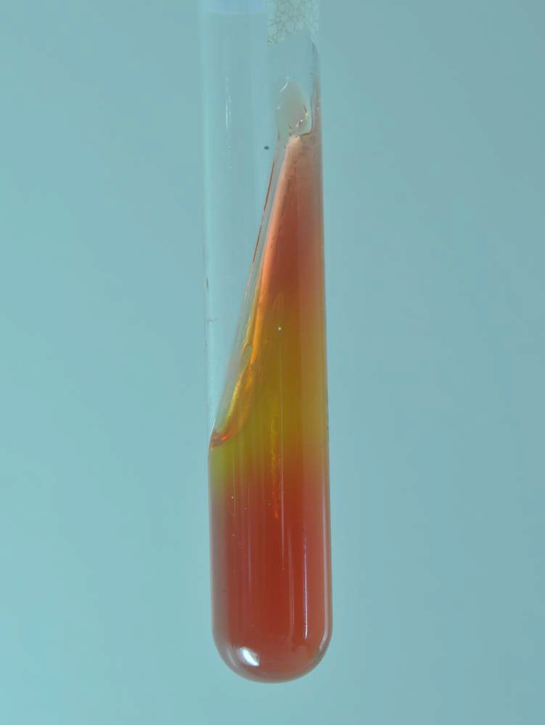

TSI Reactions

Acid reaction (A) = yellow color Alkaline reaction (K) = red color
Hydrogen Sulfide production (H2S) = black color or precipitate Gas production (G) = bubbles, cracks, or media displacement

Reactions (slant/butt) | Symbol | Interpretation
Yellow/Yellow | A/A | Glucose in addition to lactose and/or sucrose
Yellow/Yellow with gas production | A/A, G | Glucose in addition to lactose and/or sucrose, gas produced
Yellow/Yellow with black precipitate | A/A, H2S | Glucose in addition to lactose and/or sucrose, hydrogen sulfide produced
Red/Red | K/K | No carbohydrate fermentation (non‐ fermenter)
Red/Yellow | K/A | Glucose fermentation only
Red/Yellow with gas production | K/A, G | Glucose fermentation only, gas produced
Red/Yellow with black precipitate | K/A, H2S | Glucose fermentation only, hydrogen sulfide produced
Red/Yellow with gas production and black precipitate | K/A, G, H2S | Glucose fermentation only, gas produced, hydrogen sulfide produced

A/A A/A | A/A | K/A | K/A | K/A | K/A K/K
Gas | Hydrogen |  | Gas | Hydrogen | Gas
 | Sulfide |  |  | Sulfide | Hydrogen Sulfide

This job aid is a component of the free, on-demand CDC training course “Biochemicals and Gram Negative Organism ID.” Find the course at https://www.cdc.gov/labtraining.

