Facilitator Guide for Basic Microscopy Laboratory Exercises

Introduction
The Basic Microscopy Course is a blended learning activity that includes both eLearning and hands-on laboratory exercises. Both components of the course are equally important in providing knowledge and actual laboratory experience to the participant. This facilitator guide is meant to serve as a manual for the supervisor/mentor that will be overseeing the completion of the laboratory exercises after the eLearning activity has been completed. The manual contains instructions for the overall laboratory exercise components, objectives, laboratory setup, a supply list, and laboratory exercises, instructions and answer key as well as job aids.
The goal of these exercises is to allow the participant to use the information and procedures learned during the eLearning portion of the course and apply them using hands-on laboratory exercises. Please note: These laboratory exercises may be edited according to your laboratory’s standard operating procedures or guidelines, if necessary. The job aids and laboratory
exercises were created with the forethought that laboratory procedures may vary from laboratory to laboratory and therefore, may need to be edited according to the procedures or protocols followed within that laboratory.
The participant of the course is strongly recommended to complete the laboratory exercises to transfer the didactic content of the course to experiential knowledge gained through hands-on laboratory exercises with the equipment from their laboratory. The supervisor/mentor should work with the participant to develop these laboratory skills as well as confirm that these exercises have been completed. The number and types of exercises completed will be at the discretion of the supervisor/mentor based on procedures followed within their laboratory. After the laboratory exercises are completed and discussed with the supervisor/mentor, the supervisor/mentor should then follow-up the exercises with instruction related to your laboratory’s specific procedures or guidelines.

Laboratory Exercise Objectives

After completing the laboratory exercises, the participant will be able to:
- Correctly identify various parts of a brightfield microscope.
- Utilize the Kӧhler illumination procedure and job aid to correctly perform Kohler illumination on a brightfield microscope.
- Apply focusing techniques for the 10X, 40X, and 100X objectives to achieve optimal field of view.
- Use the 100X objective with oil immersion to detect and identify microscopic microorganisms.
- Compute total magnification for the 40X high dry objective as well as other objectives.
- Apply the calibration of the ocular micrometer procedure and job aid to correctly perform ocular micrometer calibration on a brightfield microscope.
- Calculate size of a microorganism using the previously calculated ocular micrometer result.
- List the make and model of the brightfield microscope used in your laboratory.
- Describe where to find manufacturer’s instructions for the brightfield microscope.
- Demonstrate proper care, cleaning, and maintenance procedures for the brightfield microscope.
- Summarize what, when, and where to document routine maintenance performed on the bright microscope for your laboratory records.

Initial Planning for the Laboratory Exercises
- Communicate with the participant and schedule days/times to complete the laboratory exercises.
- Reserve laboratory space that has a brightfield microscope available. Note: It would be best to use a microscope that the participant will commonly use.
- Collect the supplies necessary to complete the exercises (see supply list).

Day(s) of Scheduled Laboratory Exercises
- Set up supplies for the exercises.
- Remind the participant about the use of proper PPE and laboratory equipment according to your laboratory’s procedures and safety manual.
- Participant should have a copy of the laboratory exercises and job aids as a printout from the eLearning course.
- Have participant complete each exercise with your approval. Please feel free to instruct participant as they work or after the exercise is completed. Exercises may be completed all at once or as time permits.
- Relay to the participant any information that is needed to comply with your laboratory’s standard operating procedures (SOPs) or safety procedures.

Supply List
- Personal Protective Equipment (PPE), including lab coats, gloves and eye or face protection
- Brightfield microscope with 10X, 40X, and 100X objectives
- Ocular micrometer
- Stage micrometer
- Paper towels
- 70% alcohol (bottle or swabs)
- Lens cleaning solution
- Lens paper
- Cotton tipped swabs
- Prepared microscope slides with known organism
- Immersion oil
- Biohazard bags/sharps containers: Biohazard bags can be used to discard alcohol swabs, lens, paper, and gloves. If microscope slides will be discarded after the exercises, participant’s workstations should contain biohazard bags/sharps containers to dispose of their slides properly when examination is completed.
- Pencil or wax pencil
- Basic Microscopy course job aids on Kӧhler illumination and Calibration of the Ocular Micrometer.

Laboratory Exercise I
After completing this laboratory exercise, the participant will be able to:
1. Correctly identify various parts of a brightfield microscope.

Exercise 1
Label the correct parts of a brightfield (compound) microscope.
- Have the participant complete the microscope schematic using the following word bank and the job aid (if necessary):
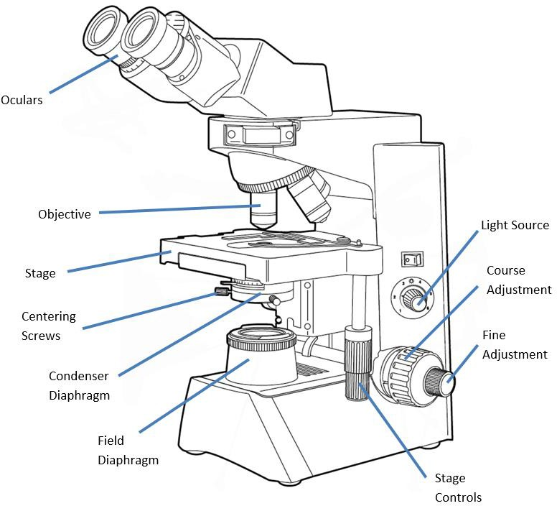
Coarse

Oculars, Objective, Stage, Centering screws, Condenser diaphragm,
Field diaphragm, Light source, Coarse adjustment, Fine adjustment, Stage controls

Exercise 2
Identify the following parts of a brightfield microscope on the bench microscope you are using.
- The participant should be able to identify the following components of the microscope in your presence.

- Objectives
- Condenser (Iris) diaphragm
- Coarse adjustment
- Fine adjustment

Notes

Mentor/Supervisor /Date

1. Utilize the Kӧhler illumination procedure and job aid to correctly perform Kӧhler illumination on a brightfield microscope.

Exercise 1
If your microscope has an adjustable field diaphragm, obtain optimal illumination using the Kӧhler illumination procedure.
Remember: You are able to use your Kӧhler illumination job aid for this exercise.
- The participant should be able to follow the Kӧhler illumination job aid (see Appendix) to achieve optimal illumination of the microscope.
- Have the participant locate the adjustable diaphragm, if one is present. Next, have the participant explain the importance and function of this procedure. If needed, review the job aid with the student to ensure their understanding.

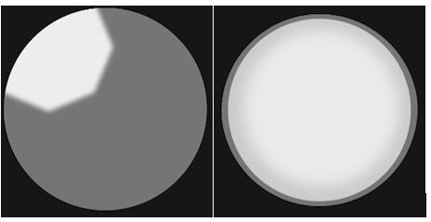
Notes

Mentor/Supervisor /Date

- Apply focusing techniques for the 10X, 40X, and 100X objectives to achieve optimal field of view.
- Use the 100X objective with oil immersion to detect and identify microscopic microorganisms.
- Compute total magnification for the 40X high dry objective as well as other objectives.(might want to swap #2 and # 3 order to help prevent students from going back to the 40x with oil if they are also doing a 100x oil step)

Exercise 1
Place a microscope slide on the brightfield microscope stage and focus on the specimen using the 10X objective. To fully focus, be sure to focus using the coarse and fine adjustment knobs. Now, move to the 40X objective and focus on the specimen. After the 10X and 40X examination has been completed, demonstrate how to look at a microscope slide using the 100X objective.
- Have the participant demonstrate their ability to focus on a specimen slide.
- Have the participant describe what they see at 40X, or be able to show the mentor/supervisor they have an image correctly focused. Complete this step again at 100X.
- Have the participant apply the information they learned on how and what to use the 100X objective with.
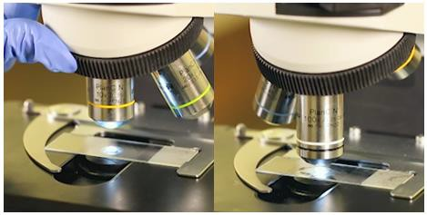
Notes

Mentor/Supervisor /Date

Laboratory Exercise III (continued)

Exercise 2
Calculate total magnification using your 40X high dry objective on your brightfield microscope.
- Have the participant calculate total magnification using the ocular eyepiece and the 40X high dry objective of the microscope.
- Verify that the participant can complete this calculation: 40X x 10X = 400X

Notes

Mentor/Supervisor /Date

Laboratory Exercise IV
After completing this laboratory exercise, the participant will be able to:
- Apply the calibration of the ocular micrometer procedure and job aid to correctly perform micrometer calibration on a brightfield microscope.
- Calculate size of a microorganism using the previously calculated ocular micrometer result.

Exercise 1
Calibrate (or practice calibrating if your microscope is already calibrated) the objectives of a brightfield microscope using an ocular micrometer. Calibrate each objective.
Remember: You are able to use your Calibration of the Ocular Micrometer job aid for this exercise.
- Have the participant demonstrate how to calibrate the objectives of the microscope beginning with the 10X objective. Allow the participant to use the ocular micrometer calibration job aid for this exercise (see Appendix).

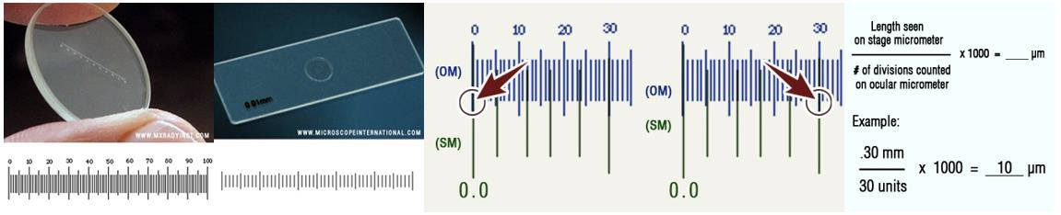
Notes

Mentor/Supervisor /Date

Laboratory Exercise IV (continued)

Exercise 2
If possible, obtain a microscope slide with an organism present. Measure the size of the organism using your new calibration factors.
- The participant should be able to apply the new calibration factors to calculate the size of an organism on a specimen slide.
- Check this measurement for accuracy.

Notes

_

Mentor/Supervisor /Date

- List the make and model of the brightfield microscope used in your laboratory.
- Describe where to find manufacturer’s instructions for the brightfield microscope.
- Summarize what, when and where to document routine maintenance or cleaning performed on the brightfield microscope for your laboratory records.

Exercise 1
Identify with the help of your supervisor/mentor the make and model of your brightfield microscope, where to find the manufacturer’s instructions, where to document routine maintenance or cleaning that is performed, and how often your microscope should be maintained or cleaned professionally.
- The participant should be able to describe important information related to the microscope in their laboratory and the requirements for microscope maintenance or cleaning/care.

Notes

Mentor/Supervisor /Date

1. Demonstrate proper care, cleaning, and maintenance procedures for the brightfield microscope.

Exercise 1
- Locate the proper supplies necessary for cleaning the microscope.
- Demonstrate the proper procedure to clean the brightfield microscope daily.
o The participant should be able to demonstrate to the supervisor/mentor the ability to properly clean the brightfield microscope. Allow the participant to use the microscope cleaning job aid (see Appendix) to complete this exercise.

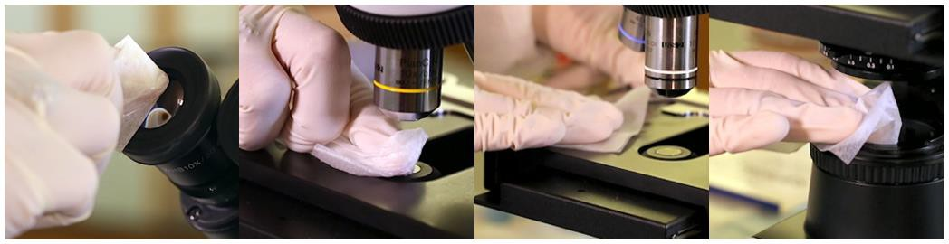
Notes

Mentor/Supervisor /Date

Appendix
The following job aids are available in the Resources area of the Basic Microscopy course to assist the participant with the procedures described in this guide. Please print or have the participant print these resources from the course.

- Components of the Microscope
- Kohler Illumination
- Focusing the Microscope
- Calibration of the Ocular Micrometer
- Care and Maintenance of the Microscope

Notes

This job aid is a component of the free, on-demand CDC training course “Basic Microscopy.” Find the course at https://www.cdc.gov/labtraining.

