Facilitator Guide for Routine Microscopy Procedures Laboratory Exercises

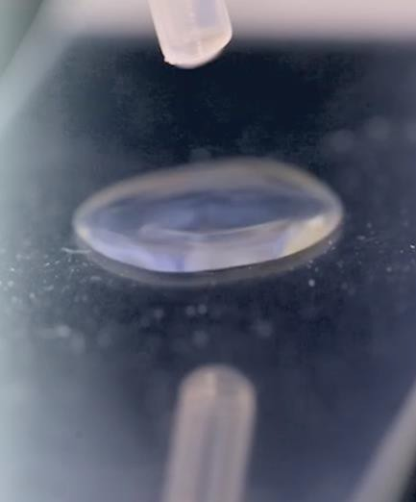Introduction
The Microbiology Curriculum: Routine Microscopy Course is a blended learning activity that includes both eLearning and hands- on laboratory exercises. Both components of the course are equally important in providing knowledge and actual laboratory experience to the participant. This facilitator guide is meant to serve as a manual for the supervisor/mentor that will be overseeing the completion of the laboratory exercises after the eLearning activity has been completed. The manual contains instructions for the overall laboratory exercise components, objectives, laboratory setup, a supply list, laboratory exercises, instructions and answer key as well as job aids.
The goal of these exercises is to allow the participant to use the information and procedures learned during the eLearning portion
of the course and apply them using hands-on laboratory exercises. Please note: These laboratory exercises may be edited according to your laboratory’s standard operating procedures or guidelines, if necessary. The job aids and laboratory exercises were created with the forethought that laboratory procedures may vary from laboratory to laboratory and therefore, may need to be edited according to the procedures or protocols followed within that laboratory.
The participant of the course is strongly recommended to complete the laboratory exercises to transfer the didactic content of the course to experiential knowledge gained through hands-on laboratory exercises with the equipment from their laboratory. The supervisor/mentor should work with the participant to develop these laboratory skills as well as confirm that these exercises have been completed. The number and types of exercises completed will be at the discretion of the supervisor/mentor based on procedures followed within their laboratory. After the laboratory exercises are completed and discussed with the supervisor/mentor, the supervisor/mentor should then follow-up the exercises with instruction related to your laboratory’s specific procedures or guidelines.

This job aid is a component of the free, on-demand CDC training course “Routine Microscopy Procedures.” Find the course at https://www.cdc.gov/labtraining.

Laboratory Exercise Objectives

Laboratory Exercise Objectives
After completing the laboratory exercises, the participant will be able to:
- Outline the steps of preparing a smear.
- Express the purpose of the Gram stain procedure.
- Identify the types of reagents used in the Gram stain procedure.
- Sequence the steps in the Gram stain procedure.
- Interpret the results seen in the bacterial cells, with the effects of the various reagents during the Gram stain procedure.
- Outline the potassium hydroxide (KOH) procedure and its uses.
- Identify how to prepare and interpret a wet mount.
- Identify the steps and results obtained in the India Ink procedure.
- Identify and resolve commonly encountered problems during routine microscopy procedures.

Initial Planning for Laboratory Exercises

Initial Planning for the Laboratory Exercises

- Communicate with the participant and schedule days/times to complete the laboratory exercises.
- Reserve laboratory space that has available a brightfield (compound) microscope and a sink for staining.
  - Note: It would be best to use a microscope that the participant will commonly use.
- Collect the supplies necessary to complete the exercises (see supply list).

Day(s) of Scheduled Laboratory Exercises
- Set up supplies for the exercises.
- Remind the participant about the use of proper PPE and laboratory equipment according to your
laboratory’s procedures and safety manual.
- Participant should have a copy of the laboratory exercises and job aids as a printout from the eLearning course.
- Have participant complete each exercise with your approval. Please feel free to instruct participant as they work or after the exercise is completed. Exercises may be completed all at once or as time permits.
- Relay to the participant any information that is needed to comply with your laboratory’s standard
operating procedures (SOPs) or safety procedures.

Initial Planning for Laboratory Exercises Cont.

Supply List
- Personal protective equipment
- Brightfield (Compound) microscope with 10X, ,20X, 40X, and 100X objectives
- Immersion oil
- Lens paper
- Lens cleaning solution
- Microscope slides, frosted-edge
- Cover slips
- Loops (sterile plastic or metal)
- Sterile pipettes
- Slide rack
- Slide warmer or Bunsen burner (optional for heat fixing the smear)
- Absorbent paper, such as bibulous paper
- Agar plate containing isolated colonies
- Specimen or sample containing Trichomonads
- Specimen containing Yeast
- Specimen containing Clue cells
- Pencil or wax pencil
- Biohazard waste container: used for personal protective equipment, alcohol swabs and lens paper.
- Sharps container: For microscope slides if they will be discarded after the examination is completed.

Reagent List
  - Sterile saline or water
  - Methanol (optional for fixing the smear)
  - Crystal violet
  - Gram’s iodine

  - Decolorizer
  - Safranin (or carbol fuschin)
  - Potassium Hydroxide (KOH)

Laboratory Exercise I: Smear Preparation

Laboratory Exercise I Objective
After completing this laboratory exercise, the participant will be able to:
    - Demonstrate the ability to perform a smear preparation.

Laboratory Exercise I: Making a Smear
Prepare a thin, even smear for subsequent staining.
- Have the participant prepare a smear following the job aid (if necessary) or your laboratory’s standard operating procedure.
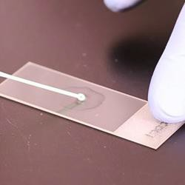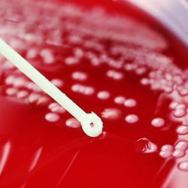

Notes

Laboratory Exercises II: Gram Stain

Laboratory Exercise II Objective
After completing this laboratory exercise, the participant will be able to:
    - Utilize the Gram stain procedure to correctly perform a Gram stain.

Laboratory Exercise II: Performing a Gram Stain
Perform a Gram stain on a fixed smear using the procedure on the job aid or your laboratory’s standard operating procedure. You may substitute your laboratory’s gram stain procedure times if different than the job aid.
- The participant should be able to follow the Gram stain job aid (see Appendix) to perform a Gram stain.
- Have the participant demonstrate their ability to focus on the prepared slide.
- Have the participant describe what they see at 40X.
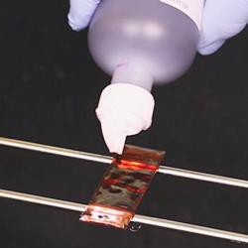

Notes

Laboratory Exercises III: Wet Mount

Laboratory Exercise III Objective
After completing this laboratory exercise, the participant will be able to:
    - Prepare a Wet Mount.

Laboratory Exercise III: Making a Wet Mount
Make a Wet Mount using the procedure on the job aid or your laboratory’s standard operating procedure.
- The participant should be able to follow the Wet mount job aid (see Appendix) to prepare a wet mount.
- Have the participant demonstrate their ability to focus on the wet mount slide at 10X.
- Have the participant describe what they see at 10X and 40X.

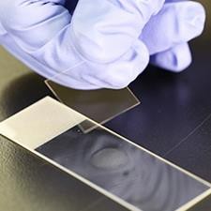

Notes

Laboratory Exercises IV: KOH Procedure

Laboratory Exercise IV Objective
After completing this laboratory exercise, the participant will be able to:
    - Perform the potassium hydroxide (KOH) procedure.

Laboratory Exercise IV: Performing a KOH Procedure
Perform a KOH procedure as described in the job aid or using your laboratory’s standard operating procedure.
- The participant should be able to follow the KOH job aid (see Appendix) to
- perform a KOH procedure.
- Have the participant demonstrate their ability to focus on the prepared KOH slide.
- Have the participant describe what they see at 40X.
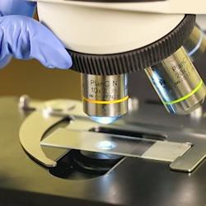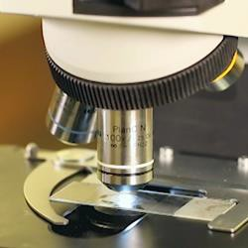

Notes

Smear Preparation

Introduction
The process of making a smear preparation is an important skill in the microbiology laboratory and is usually the first step in most staining procedures. The quality of the smear will directly affect the quality of the subsequent staining procedure. The smear preparation differs slightly depending on the specimen or culture.

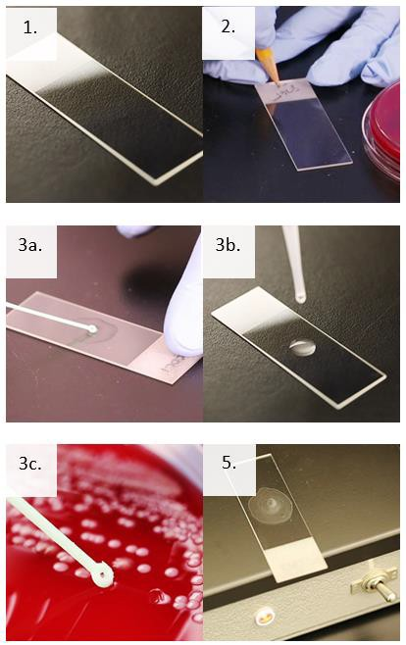
Supplies
- Personal protective equipment
- Sharps container
- Biological waste container
- Microscope slides with frosted-edge
- Pencil or wax pencil
- Sterile saline or water
- Sterile pipettes
- Loops or applicator sticks
- Slide warmer, Bunsen burner, or methanol

Instructions
- Be sure to wear appropriate personal protective equipment (PPE) to include gloves, laboratory coat, and face and eye protection, as indicated in your laboratory's SOP and safety manual.
- Obtain a clean microscope slide with a frosted edge.
- Label the frosted edge appropriately with the sample identification.
- Transfer specimen or culture to the center of the slide.
  - Clinical Specimen: Prepare a thin layer of cells on the slide. Refer to your laboratory’s procedure according to different specimen types.
  - Broth Culture: Using a sterile pipette, transfer 1-2 drops to the slide. Spread the drop into a thin, even smear.
  - Culture from solid media: Using a sterile pipette, add one drop of sterile saline or sterile water to the center of the microscope slide. Aseptically pick a small amount of an isolated colony with a loop and gently mix into the drop of sterile saline or water using circular motions. Mix evenly to make a thin smear.
- Allow the smear to air dry completely.
- Fix the smear to the slide using heat fixation or methanol fixation according to your laboratory’s procedure.
- Allow the slide to cool to room temperature or air dry.
Note: Do not drag the 40X objective through the oil.

Gram Stain

Introduction
The Gram stain is a differential staining procedure used to categorize bacteria as Gram-positive or Gram-negative based on the chemical and physical properties of their cell walls. The bacteria are differentiated through a series of staining and decolorization steps. Gram-positive cells will stain purple and Gram-negative cells will stain red to pink.

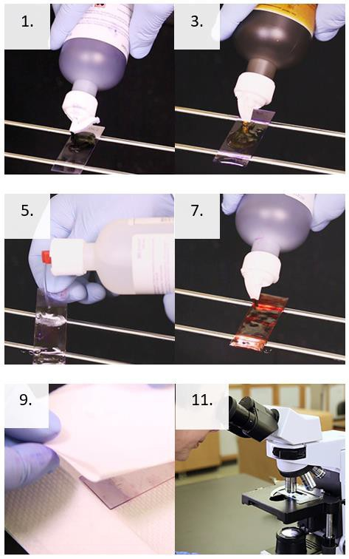
Supplies and Reagents
- Personal protective equipment
- Slide rack
- Timer
- Absorbent paper, such as bibulous paper
- Water (tap water or deionized)
- Crystal violet
- Gram’s iodine
- Decolorizer
- Safranin (or carbol fuchsin)
- Brightfield microscope with 100X objective
- Immersion oil
- Pencil

Instructions
- Place the prepared fixed smear on a slide rack then flood the slide with crystal violet.
- Wait 15 seconds then rinse the slide with water.
- Flood the slide with Gram’s iodine.
- After 15 seconds rinse the slide with water.
- Apply the decolorizer to the slide.
- Rinse the slide immediately with water.
- Flood the slide with counterstain.
- Wait 15 seconds then rinse the slide with water.
- Blot the slide with absorbent paper. Be careful not to wipe the cells off the slide.
- Allow the newly stained slide to air dry completely.
- View the slide under oil using the oil
immersion objective for a total magnification of 1000X.
- Record results based on your laboratory’s criteria.

Preparing a Wet Mount

Introduction
The Wet Mount is a procedure performed in the laboratory to observe motile organisms. It is commonly used to examine material collected from the vaginal wall of a female patient.

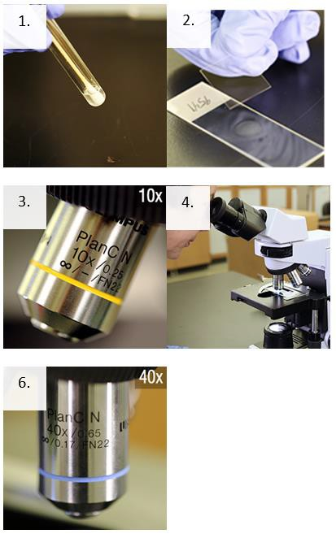
Supplies
- Personal protective equipment
- Sharps container
- Biological waste container and bag
- Sterile microscope slides
- Sterile pipettes
- Glass coverslips
- Pencil

Instructions
- Using a sterile dropper, gently mix and remove some of the specimen from the tube and place one drop (10µL) on a clean microscope slide with the patient’s identification number/name.
- Immediately put a coverslip over the sample for examination. A microscopic review of the slide should be performed as soon as possible to confirm the presence or absence of Trichomonads.
- Focus with low power (10X), low light.
- Scan the entire slide.
- Read at least 10 fields.
- Identify objects with high power (40X).
- Record results based on your laboratory’s criteria.

KOH Procedure

Introduction
The KOH (Potassium hydroxide) procedure is a method used to examine specimens for yeast. KOH serves as an enzymatic agent that breaks down debris in a specimen, such as epithelial cells and WBCs, to view yeast or pseudohyphae.

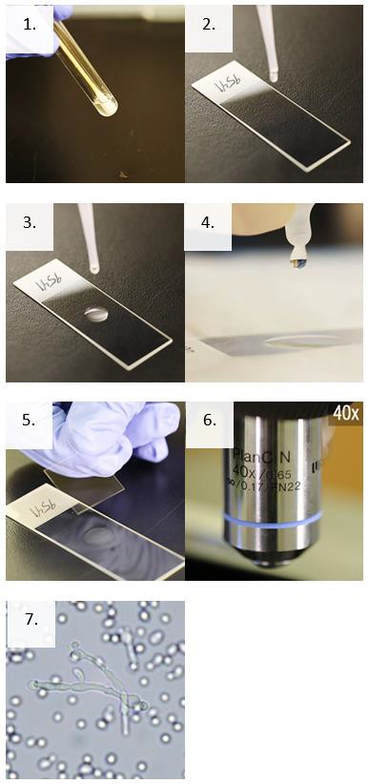
Supplies
- Personal protective equipment
- Sharps container
- Biological waste container and bag
- Sterile microscope slides
- Sterile pipettes
- Glass coverslips
- Potassium hydroxide (KOH)

Instructions
- Mix the specimen well.
- Using a sterile pipette, remove one drop or 10 microliters of the specimen from the tube.
- Place one drop (10 µL) of the specimen on a clean microscope slide with the patient’s identification number.
- Without touching the specimen, add one drop (10 µl) of 10% Potassium hydroxide (KOH) directly to the drop of specimen on the slide.
- Place a coverslip on the drops on the slide.
- Place the slide on a brightfield microscope, focus using low power (10X), and scan at least 10 fields using high dry power (40X).
- Examine for budding yeast or yeast with pseudohyphae.
- Record results based on your laboratory’s criteria.

