Gram stain: Francisella tularensis

•Faintly-staining, tiny, pleomorphic, Gram-negative coccobacilli
•Mostly single cells (0.2-0.5 x 0.7-1.0µm)
Colony morphology:
•Smooth, shiny, and butyrous
•Tiny, grey-white, and opaque on Sheep Blood agar, Chocolate agar, Thayer- Martin agar, and BCYE agar
Growth:
•Usually too small to be seen at 24h
•May require cysteine supplementation
•Scant to no growth on Sheep Blood agar after 48h
•No growth on MacConkey or EMB agar
•Slow growth in broth Biochemicals:
•Oxidase and satellite (or XV) negative
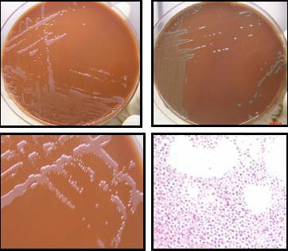
•Catalase negative or weakly positive
•Beta-lactamase positive

Refer Cultures to your
LRN Reference Lab

Rev. 12/09/2013

