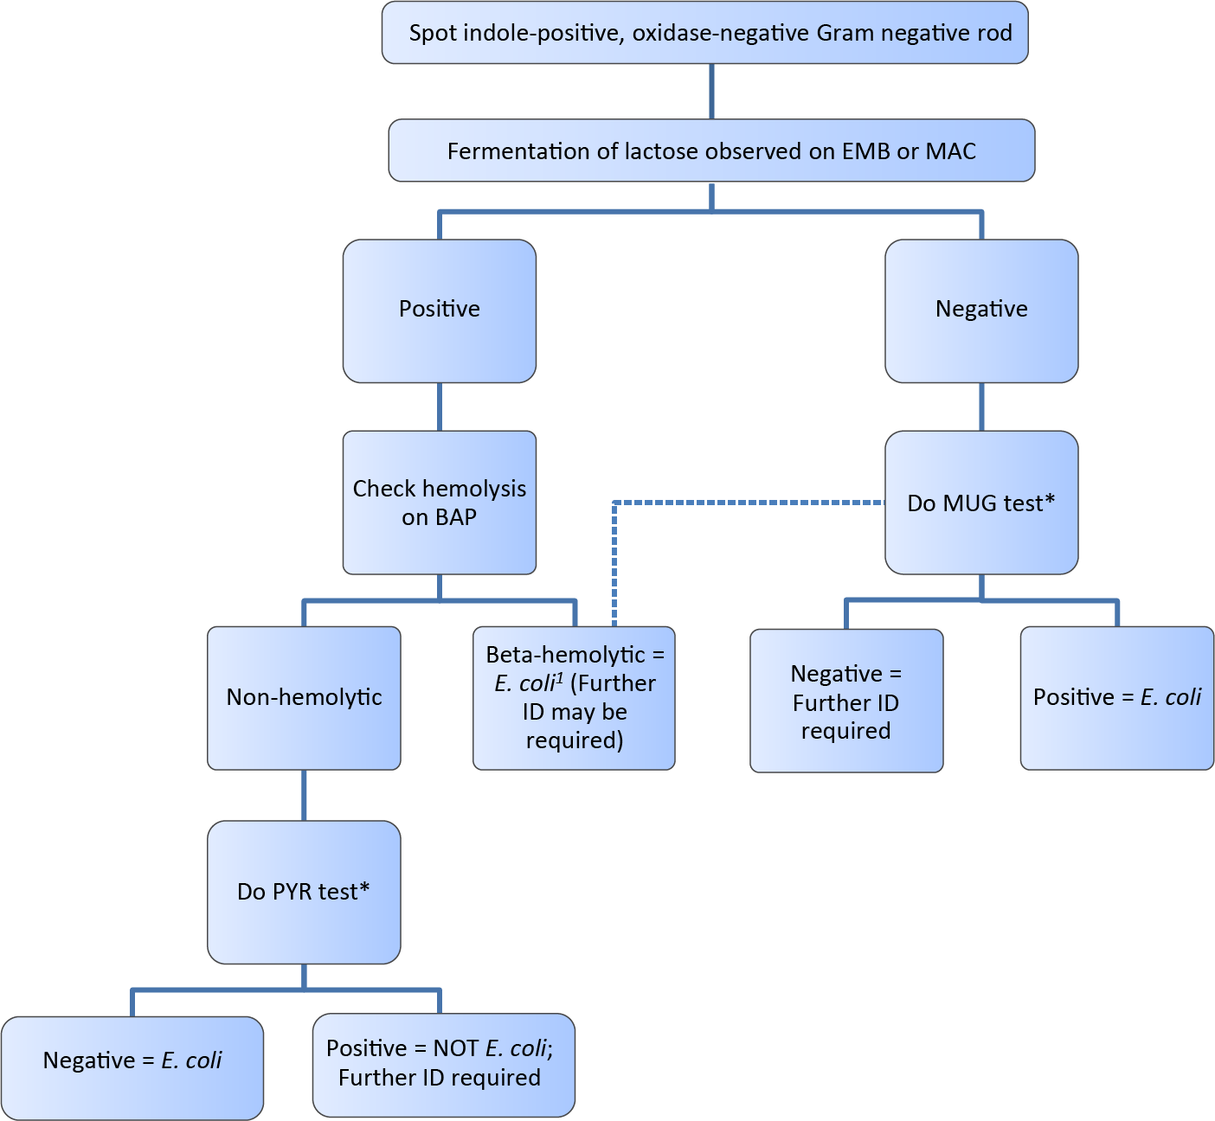
Escherichia coli (non-stool) ID chart
1 = LAC-negative, beta-hemolytic colonies could be
M. morganii, E. tarda, or P. vulgaris. In some populations, these may all be E. coli2 and the MUG test is not needed, especially for isolates from noninvasion sites.
2 = York M K et al. J. Clin. Microbiol. 2000; 38:3394-3398
* = See Biochemical Tests for Gram Negative Organism ID Job aid for positive and negative result reference.

