Continuity of Operations Decision Process Flowchart

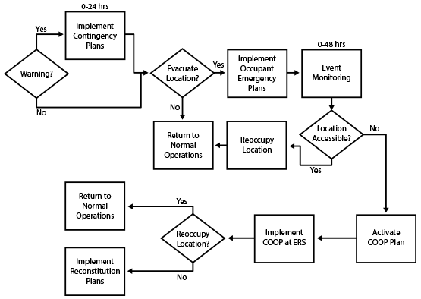

This job aid is a component of the free, on-demand CDC training course “Laboratory Continuity of Operations.” Find the course at https://reach.cdc.gov/training.

v.23030

