Calibration of the Ocular Micrometer
Introduction
This is a simple and precise method for measuring objects seen in the microscope. Ocular micrometers are calibrated by comparing the ocular micrometer scale with a calibrated stage micrometer. A calibration procedure must be completed to determine the calibration factor for each objective and each microscope.
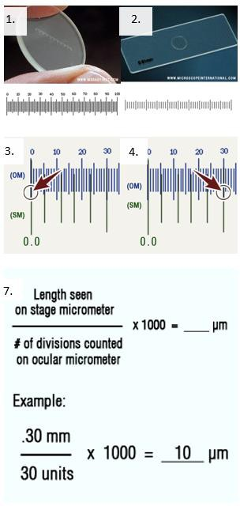
Instructions

- Insert the ocular micrometer into a 10X eyepiece. The ocular micrometer is divided into ocular divisions (OD).
- Place the calibrated stage micrometer slide on the stage and focus on the scale. The stage micrometer has a calibrated scale which is divided into 0.1 millimeters (mm) and 0.01 mm units.
- Adjust the field so the 0 line of the ocular micrometer (OM) scale is exactly superimposed upon the 0.0 line of the stage micrometer (SM) scale.
- Without moving the stage micrometer, locate the point as far to the extreme right as possible where any two lines are exactly superimposed upon each other.
- Count the number of divisions (mm) on the stage micrometer between the 0.0 line and the superimposed line to the far right.
- Count the number of ocular divisions on the ocular micrometer between the 0 line and the superimposed line to the far right.
- Divide the distance determined in step 5 by the number of ocular divisions in step 6 and multiply by 1000 to give the ocular micrometer units in µm.
- Repeat steps 3 through 7 for each objective on the microscope.
- If at any time the ocular micrometer is moved to a different microscope or a new objective is added to the microscope, the calibration procedure must be completed again.

This job aid is a component of the free, on-demand CDC training course “Basic Microscopy.” Find the course at https://www.cdc.gov/labtraining.

