Brucella spp. Characteristics Chart

Gram stain:
- Small, faintly staining Gram-negative coccobacilli (0.4 x 0.8μm)

Colony morphology:
- Light “dust” of growth after 24h
- Punctate on Sheep Blood agar at 48h
- Smooth, convex, and raised with an entire edge on Chocolate and Sheep Blood agar after 48h
- Non-pigmented; non-hemolytic
Growth:
- Slow upon primary isolation; most require CO2 incubation
- No growth on MacConkey or Eosin Methylene Blue agar (infrequently, pinpoint colonies on MacConkey after extended incubation – 7 days)
- Does not satellite around S. aureus (does not require X & V factors)
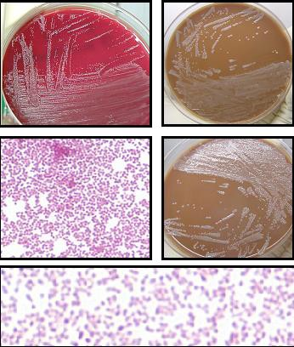
Biochemicals:
- Oxidase, catalase, and urease positive

Refer Cultures to your LRN Reference Lab

