Bacillus anthracis

Gram stain:
- Large Gram-positive rod (1-1.5 x 3-5μm)
- Central to subterminal spores
- Single, short chains, or long
chains Colony morphology:
- Grey, ground-glass appearance
- Irregular borders on Sheep Blood agar; “Medusa head”, “comet tail”, or “comma-shaped projections”
- Tenacious consistency; stands up when teased with
a loop
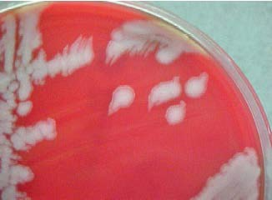
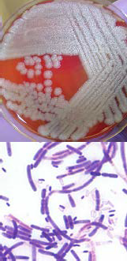
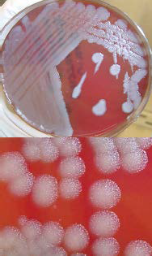
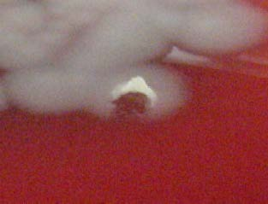
- Flat or slightly convex
- Non-hemolytic

Growth:
- Rapid on Sheep Blood
agar (growth 6-8h,
individual colonies 12-15h)
- No growth on MacConkey
agar Motility:
- Motility – Negative

Refer Cultures to your LRN Reference Lab

