Alpha Streptococci vs Streptococcus pneumoniae ID Chart

Summary

Alpha-hemolytic Streptococci (green color) on blood agar; do not grow on MacConkey; catalase negative

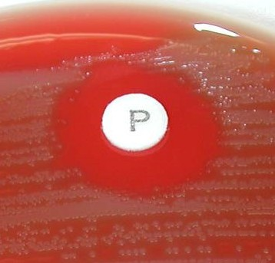
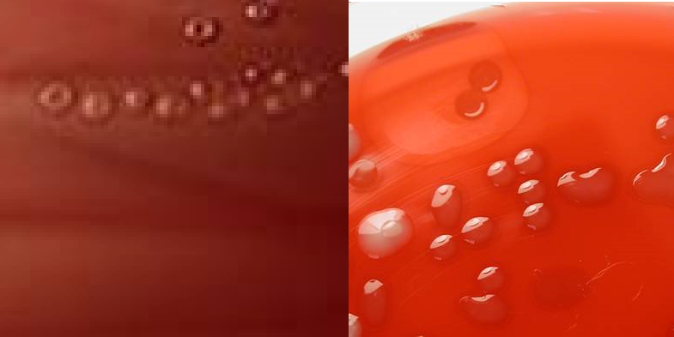
Streptococcus pneumoniae
1.
2.
3.

Characteristics

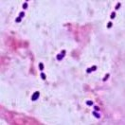
- Colonies more mucoid and may have concave centers.
4.
- Dissolve in 10 min with bile (sodium desoxycholate)
- Optochin (P) disk sensitive (zone).
- Gram positive cocci in pairs. May be lancet shaped.

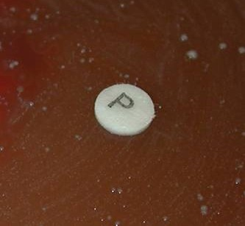
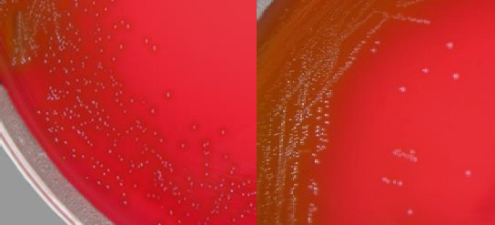
Viridans Streptococci Characteristics
1.
2.
3.

- Pathogens are only in blood cultures.
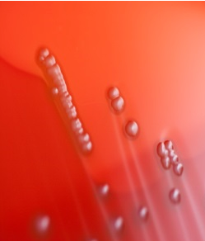
- Colonies are smaller and drier.
4.
- No zone around Optochin
(P) disk.
- Will not dissolve with bile.

