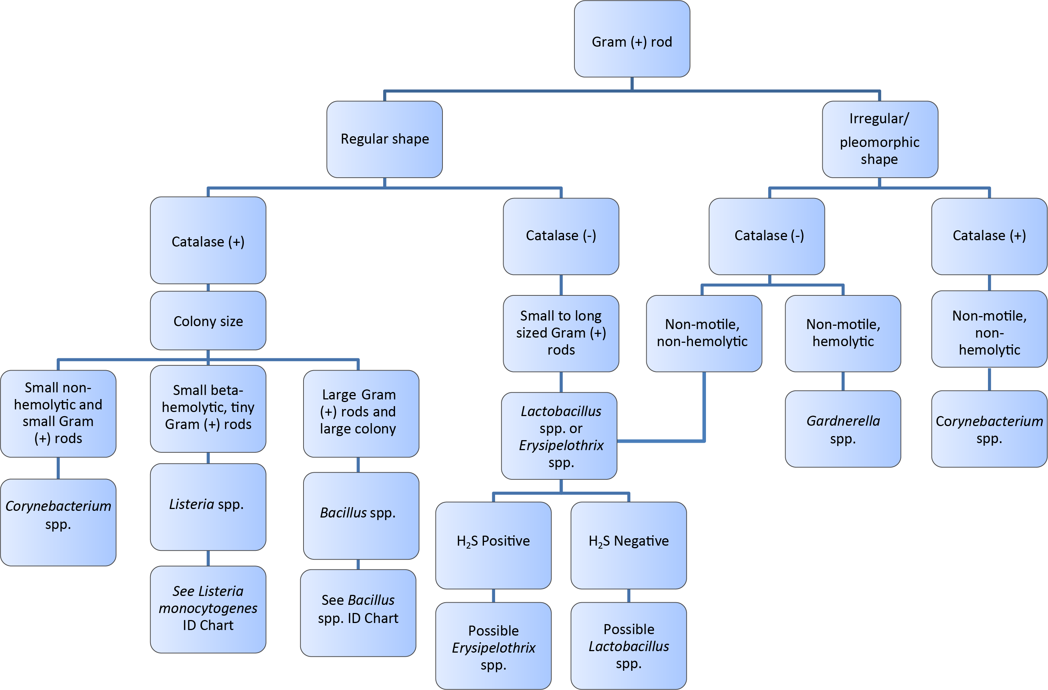
Aerobic Gram Positive Rods Flowchart

